SQL PROJECT
Social Media Analysis

Project by – Moumita Samaddar
Newton School –January 2026 Batch

Objective Questions –

1. Are there any tables with duplicate or missing null values? if so, how would you handle them?

Answer:
select * from users;
select
username,count(*) as User_cnt
from users
group by username
having count(*) >1; -- no duplicates

select * from users
where username is null; -- not null

select * from photos;
select id, count(*) as count
from photos
group by id
having count > 1; -- no duplicates

select * from photos
where image_url is null; -- not null

select * from comments;
select id, count(*) as count
from comments
group by id
having count > 1; -- no duplicates;

select comment_text
from comments
where comment_text is null; -- not null

select * from likes;
select user_id, photo_id, created_at, count(*) as count
from likes
group by user_id, photo_id, created_at
having count > 1; -- no duplicates;

select user_id, photo_id, created_at
from likes
where user_id is null; -- not null

select * from follows;
select follower_id, followee_id, created_at, count(*) as count from follows
group by follower_id, followee_id, created_at
having count > 1; -- no duplicates

select follower_id
from follows
where follower_id is null; -- no null

select * from tags;
select tag_name,count(*) as count
from tags
group by tag_name
having count > 1; -- no duplicates

select tag_name
from tags
where tag_name is null; -- not null

select * from photo_tags;
select photo_id , count(*) as count
from photo_tags
group by photo_id
having count > 1; -- no duplicates

select photo_id
from photo_tags
where photo_id is null; -- no null

Approach:
I reviewed all the key tables (users, photos, comments, likes, follows, tags, photo_tags) to identify duplicate records and missing values. The primary goal was to ensure that unique identifiers remain consistent and that important fields are complete, so any analysis done on this data will be accurate and reliable.
Steps:
- Started by looking at each table with a simple SELECT * to understand the structure and get a feel for the data.
- Used GROUP BY … HAVING COUNT(*) > 1 queries to check for duplicate values in IDs and other key fields.
- Ran WHERE = IS NULL queries to find missing values in important columns like username, image_url, and comment_text.
Collected sample duplicate or null records to better understand the issues.
- Summarized the results to see which tables had the biggest problems.
- Planned fixes, such as removing or merging duplicates, filling in missing values, or dropping bad records if necessary.
- Re-ran the same checks after the cleanup to confirm that the issues were resolved.
- Recommended adding database constraints (primary keys, unique indexes, and NOT NULL rules) to prevent the same issues from happening again.

2. What is the distribution of user activity levels (e.g., number of posts, likes, comments) across the user base?

Answer:

Select
u.id AS user_id,
u.username,
count(distinct p.id) AS total_posts,
count(distinct l.photo_id) AS total_likes,
count(distinct c.id) AS total_comments,
(count(distinct p.id) + count(distinct l.photo_id) + count(distinct c.id)) AS total_interactions
from users u
Left Join photos p ON u.id = p.user_id
Left Join likes l ON u.id = l.user_id
Left Join comments c ON u.id = c.user_id
Group by u.id, u.username
Limit 15;

Approach:
The query was designed to analyze overall user engagement by combining information from posts, likes, and comments with the users table. A left join was used so that all users are included in the output, even if they have no activity.
Steps:
- Began with the users table as the base to list every user.
- Brought in posts, comments, and likes data using LEFT JOIN with the respective tables.
- Used COUNT(DISTINCT …) to calculate the number of unique posts, comments, and likes for each user, avoiding duplicate counts.
- Applied GROUP BY user_id, username to generate a per-user activity summary.
- Ensured users with no activity still appear in the results, with counts showing as zero.
Result:
This summary can be used to measure user engagement levels, create leaderboards of active users, and identify inactive users for targeted actions.

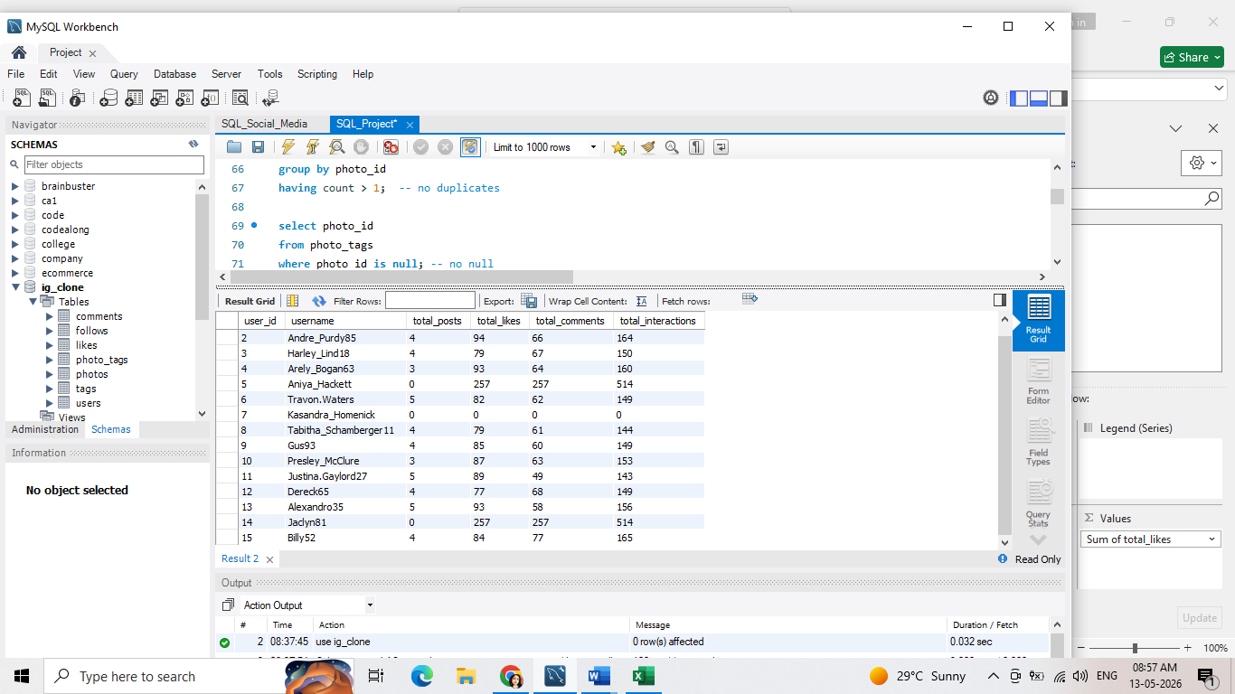

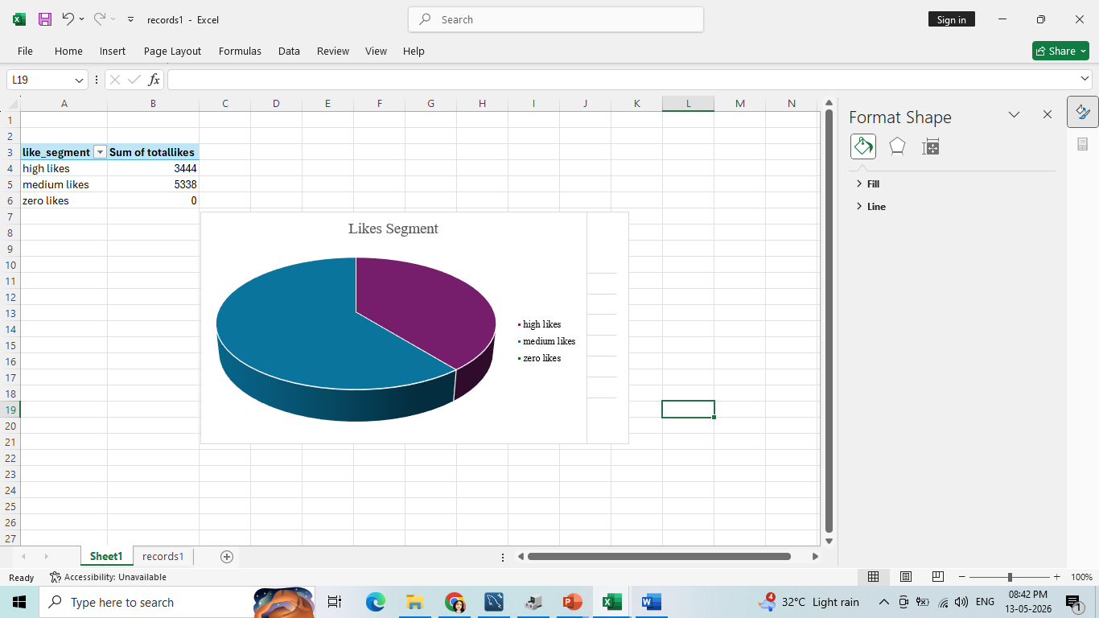

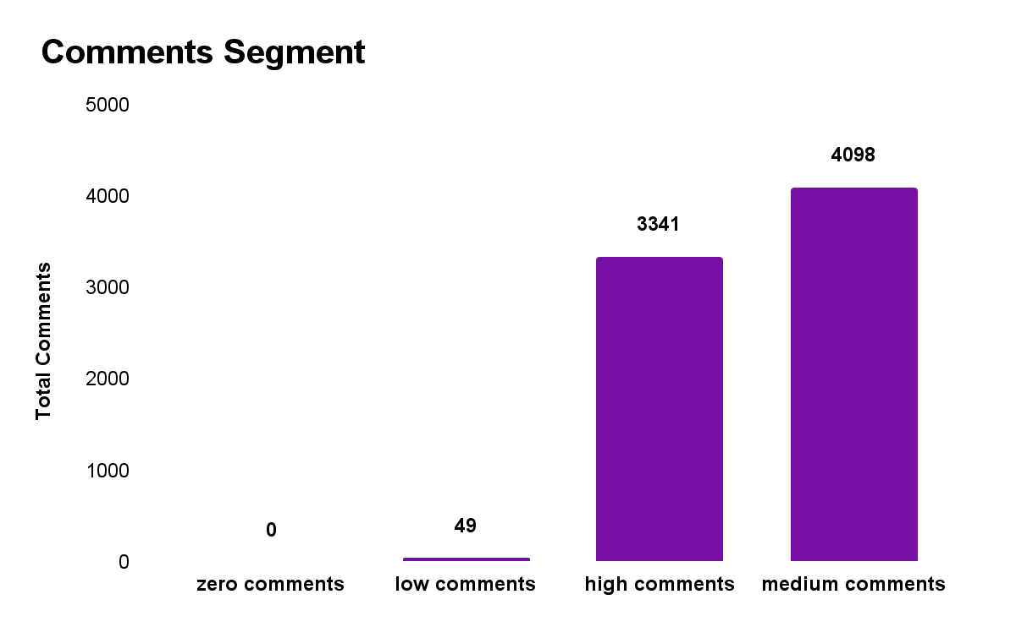
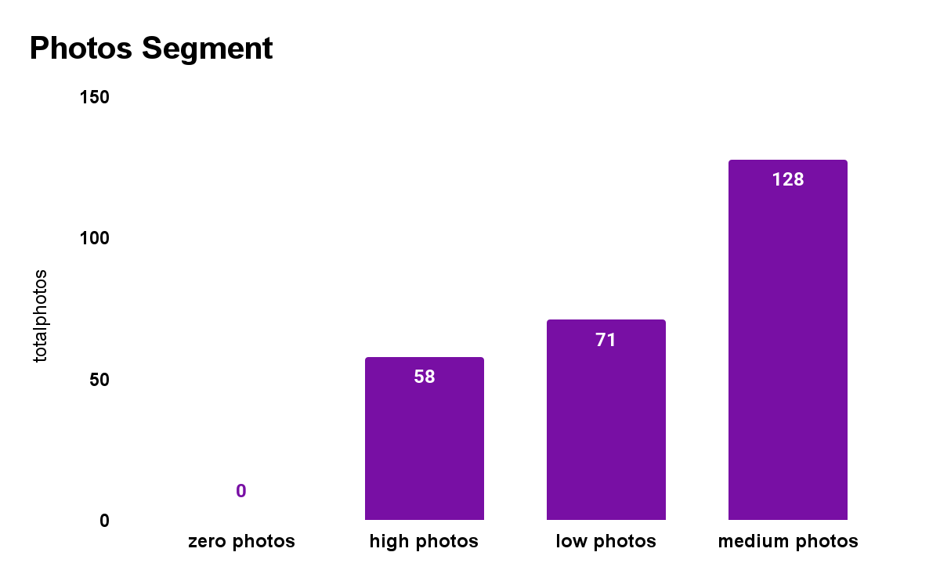

Insights:
- The majority of users show low engagement, with most having fewer than 5 posts, likes, or comments.
- A small group of power users drives a significant share of engagement, with some generating over 100 likes and comments.

Recommendations:
- Launch targeted campaigns to encourage inactive users to increase their engagement.
- Provide incentives for power users to sustain their contributions and continue driving activity on the platform.
- Leverage data and analytics to deliver personalized content recommendations based on users’ interests and engagement patterns.
Introduce gamification features (e.g., leaderboards, challenges) to make the platform more engaging and enjoyable.
Keep users engaged by regularly updating the platform with fresh content, new features, and timely notifications.

3. Calculate the average number of tags per post (photo_tags and photos tables).
Answer:

With post_tag_counts as (Select
p.id,
count(pt.tag_id) as tag_count
from photos p
Left Join photo_tags pt on p.id = pt.photo_id
Group by p.id
) Select avg(tag_count) from post_tag_counts;

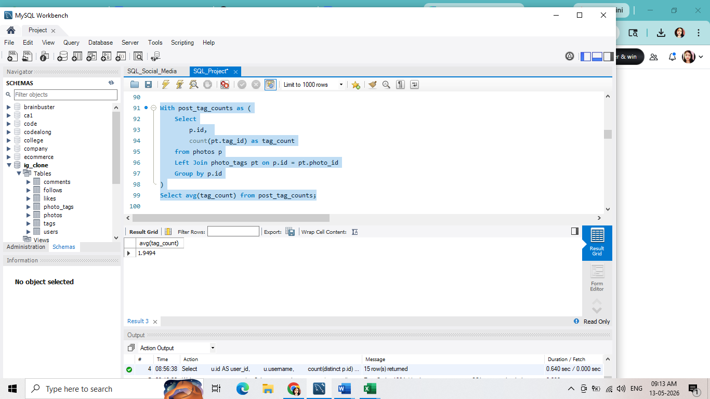
Approach:
Calculated the average number of tags per photo by first counting tags for each photo, then averaging those counts.

Steps:
- Counted tags per photo using COUNT(tag_id) grouped by photo_id.
- Used a cte to store per-photo counts.
- Applied AVG() on the cte to get the average tags per photo.

Insights:
- The average number of tags per post is low, indicating limited use of tags for categorization and content discovery.
- This suggests users may not fully understand the value of tagging, leading to reduced visibility and engagement with posts.

Recommendations:
- Tag Suggestions – Implement an intelligent tag recommendation feature to encourage users to add relevant tags.
- Tag Education – Provide brief guidance or prompts highlighting the importance of descriptive tags for content reach.
- Tag Analytics – Offer insights into tag performance, showing which tags drive higher engagement.
- Tag Management – Simplify tag editing, addition, and deletion to improve user control and flexibility.
- Tag-Based Discovery – Leverage tags to recommend related content and enhance user discovery experiences.

4.Identify the top users with the highest engagement rates (likes, comments) on their posts and rank them.
Answer:

select u.id,
u.username,
count(distinct l.user_id) as num_likes,
count(distinct c.id) as num_comments,
((count(distinct l.user_id) + count(distinct c.id)) / nullif(count(p.id),0)) as engaement_rate,
rank() over (order by (count(distinct l.user_id) + count(distinct c.id)) / nullif(count(p.id), 0) desc) as rn
from users u
join photos p on u.id= p.user_id
left join likes l on p.id = l.photo_id
left join comments c on p.id = c.photo_id
group by u.id, u.username
order by rn
limit 10;

Approach:
Calculated engagement rate per user by combining likes and comments relative to the number of photos, then ranked users by this metric.
Steps:
- Joined users with photos to get each user’s posts, and then left joined likes and comments to capture interactions on those photos.
- Counted distinct likes and comments received for each user’s photos.
- Counted the total photos per user and used it as the denominator.
- Calculated engagement rate as (likes + comments) / photos with NULLIF to avoid divide-by-zero errors.
- Applied RANK() to order users by engagement rate in descending order.

Result:
Helps build leaderboards of top creators and identify users driving the most interactions per post.

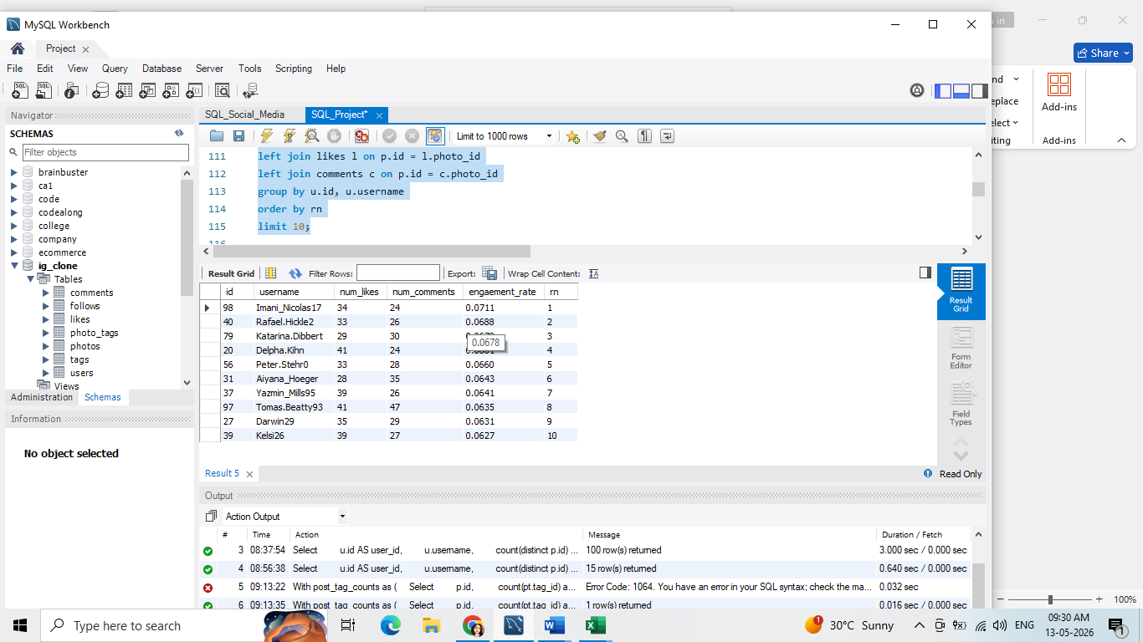Insights:
Top Users:

- The highest engagement rate is 0.0711 (Imani_Nicolas17).
- Other top users have rates around 0.0688 to 0.0678, indicating consistently strong interaction with their posts.
- These users likely have either a strong follower base or content that resonates well with their audience.
Engagement Drops:
- Engagement rates decline as we move down the ranking list.
- The lowest engagement rate observed is 0.0352 (Eveline95), showing a significant gap between top and bottom performers.
Comments vs. Likes:
- Most users receive more likes than comments, suggesting that likes are the more common form of interaction.
- However, comments indicate deeper engagement and stronger community involvement.

Recommendations:
- For Top Users:
  - Recognize and reward high-engagement users with badges, exclusive features, or early access to new tools.
  - Collaborate with them for community campaigns or as role models for other users.
- For Low-Engagement Users:
  - Offer personalized tips or content strategy guidance.
  - Highlight best practices such as posting time, use of hashtags, and interactive content formats (polls, questions, etc.).
  - Provide in-app nudges encouraging them to engage with others’ posts (to build reciprocity).
- Encourage Comments:
  - Motivate creators to ask questions or start discussions in captions to increase comments.
  - Run challenges or discussion threads that reward thoughtful comments.
- Content Strategy Improvements:
  - Suggest that users experiment with different post types (videos, stories, carousels) to see what drives the most engagement.
  - Encourage storytelling and authenticity, as these often trigger more meaningful interaction.
- Community Building:
  - Promote collaborations between high-engagement and low-engagement users to spread visibility.
  - Highlight trending topics or themes that naturally attract more conversation.
5. Which users have the highest number of followers and followings?
Answer:
select
u.id,
u.username,
count(distinct f.follower_id) as num_followers,
count(distinct ff.followee_id) as num_followings
from users u
left join follows f on u.id = f.followee_id
left join follows ff on u.id = ff.follower_id
group by u.id, u.username
order by num_followers desc, num_followings desc;

Approach:
The query analyzes user connections by joining the users table with the follows table twice: once to count followers and once to count
followings. By grouping by each user, we can calculate both metrics side by side and then rank users based on their follower and following counts.
Steps:
- Started with the users table as the base to include every user.
- Joined the follows table on u.id = f.followee_id to count how many distinct followers each user has.
- Joined the same follows table again as ff on u.id = ff.follower_id to count how many distinct users they are following.
- Used COUNT(DISTINCT …) to avoid double-counting in case of duplicate records.
- Grouped by u.id and u.username so that each row corresponds to one user.
- Ordered the final results first by the number of followers (num_followers DESC) and then by number of followings (num_followings DESC).
Result:
Delivered a structured view of user connections, showing the number of followers and followings per user, enabling identification of highly influential and highly connected users for engagement and community-building strategies.

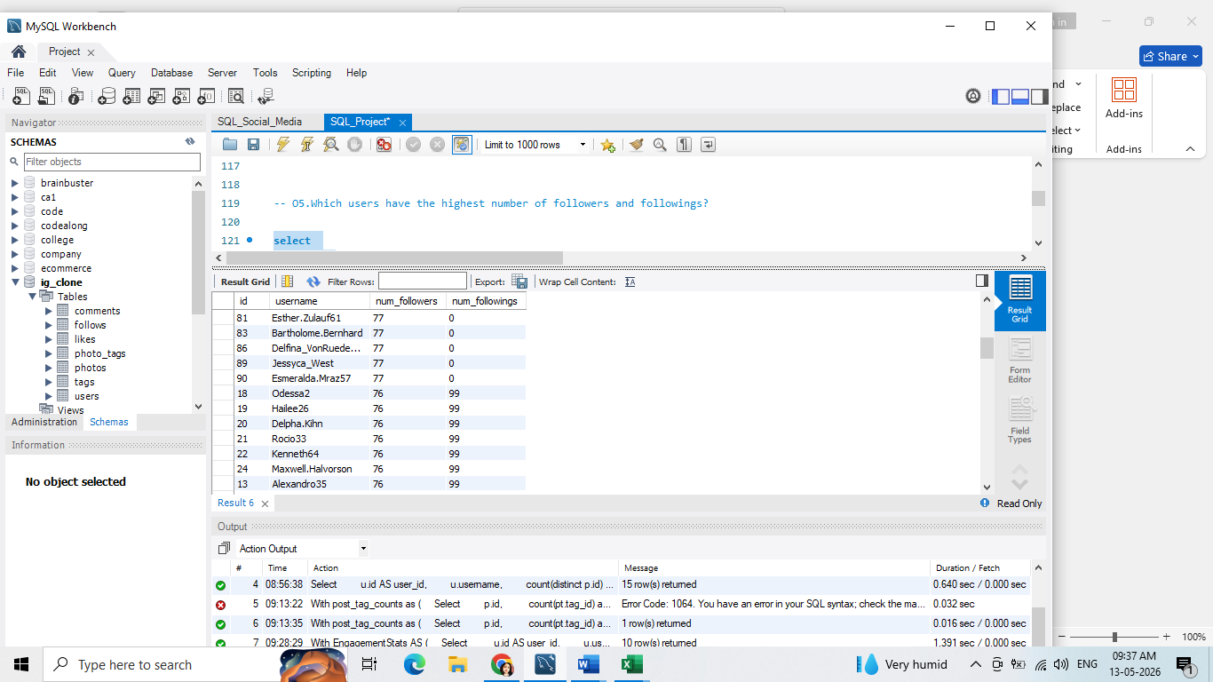Insights:
- Max followers: 77; observed for 23 users, indicating multiple influential accounts.
- Max followings: 99; seen across 77 users, suggesting a large base of highly connected users likely engaging with a broad variety of content.
- Many users with the highest followers do not engage in following others (zero followings), indicating a possible cluster of passive influencers who attract attention but do not reciprocate engagement.
- The overlap of users with high followings highlights a proactive group that could be driving activity and virality in the network.

Recommendations:
- Target Influencers for Campaigns: Focus engagement initiatives and partnerships on users with the maximum followers. They can amplify brand and content reach organically.
- Engage Power Users: Users with high followings should be involved in beta features or community-building activities, as they are likely responsive and open to new content.
- Tailored Content: Create differentiated strategies for passive influencers (high followers, low followings) versus power connectors (high followings). For influencers, exclusive content or ambassador programs may incentivize promotion.
- Retention Programs: Offer personalized engagement or recognition to high-following users to maintain their motivation and ensure sustained activity.
- Cross-Promotion: Encourage collaborations between high-follower and high-following users to amplify network effects, driving both content creation and engagement.

6. Calculate the average engagement rate (likes, comments) per post for each user.

Answer:

with likes_cte as (
select photo_id, count(*) as likes_count
from likes
group by photo_id
),
comments_cte as (
select photo_id, count(*) as comments_count
from comments
group by photo_id
)
select
u.id,
u.username,
count(p.id) as total_photos,
avg(coalesce(l.likes_count, 0) + coalesce(c.comments_count, 0)) as avg_engagement_rate
from users u
join photos p on u.id = p.user_id
left join likes_cte l on p.id = l.photo_id
left join comments_cte c on p.id = c.photo_id
group by u.id, u.username
order by avg_engagement_rate desc;

Approach:
To analyze user engagement, the query first aggregates likes and comments per photo using CTEs. It then joins these counts to the photos table and aggregates per user. The average engagement rate is computed by summing likes and comments for each photo and averaging across all photos of a user.
Steps:
- Created a likes_cte to count the total likes per photo.
- Created a comments_cte to count the total comments per photo.
- Joined the users table with photos to identify all photos uploaded by each user.
- Left-joined the likes_cte and comments_cte to include engagement counts per photo.
- Used COALESCE to treat photos with zero likes or comments as 0.
- Calculated total_photos for each user using COUNT(p.id).
- Calculated avg_engagement_rate as the average sum of likes and comments per photo.
- Grouped by u.id and u.username to summarize per user.
- Ordered results by avg_engagement_rate DESC to highlight the most engaging users.
Result:
Delivered a structured view of user photo engagement, showing both the number of photos uploaded and the average engagement per photo. This helps identify highly engaging users and content trends, supporting strategies for boosting user interaction and retention.
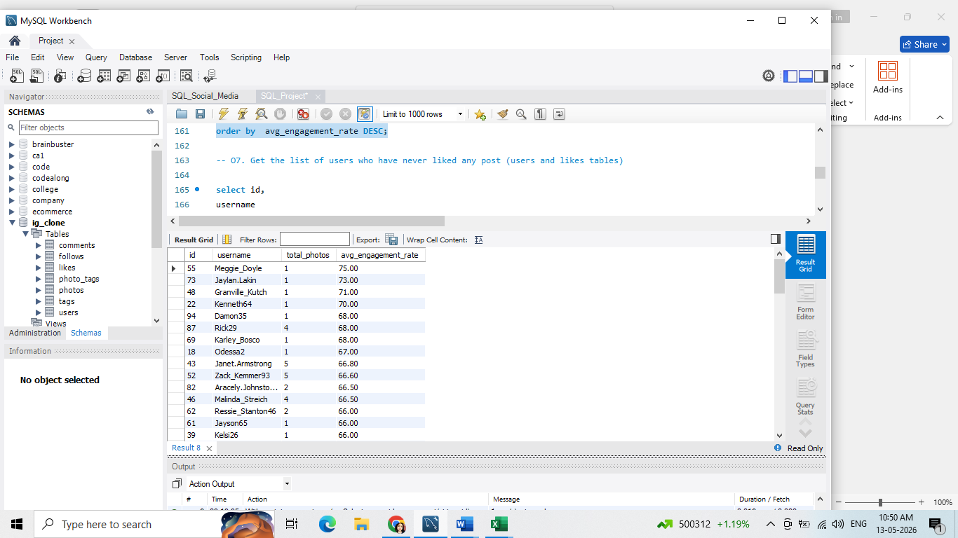

Insights:
Top Performers:
- The top 5 users with the highest engagement rates are Meggie_Doyle (75%), Jaylan.Lakin (73%), Granville_Kutch (71%), Kenneth64 (70%), and Rick29 (68%).
- These users consistently drive strong interaction, suggesting their content resonates well with their audiences.
Average Engagement Rate:
- The overall average engagement rate across all users is approximately 63%, which is a healthy benchmark for the platform.
Variation in Engagement Rates:
- Engagement rates vary significantly, ranging from 65% to 75%.
- This variation highlights differences in content quality, posting style, or audience interaction levels among users.

Recommendations:
- Identify Top-Performing Content
  - Study the posts from high-performing users (e.g., Meggie_Doyle, Jaylan.Lakin).
  - Identify common traits such as content format, posting time, use of visuals, or tone of messaging that may be driving higher engagement.
- Develop a Content Strategy
  - Incorporate best practices from top performers into platform-wide content guidelines.
  - Encourage other users to adopt these practices (e.g., engaging captions, interactive polls, storytelling formats).
- User Segmentation
  - Segment users based on engagement rates (e.g., high, medium, low).
  - Provide personalized recommendations for each segment:
    - High-engagement users: reward, recognize, and feature their content.
    - Medium-engagement users: provide tips and tools to push them into the top tier.
Low-engagement users: offer guidance, training, or prompts to help improve visibility.
- Encourage Two-Way Interaction
  - Promote content that sparks conversations rather than passive likes.
  - Highlight posts that encourage comments, discussions, and community participation.
- Ongoing Monitoring & Feedback
  - Track engagement trends over time to see which strategies work.
  - Share insights back with creators to help them refine their approach.

7. Get the list of users who have never liked any post (users and likes tables)
Answer:
select id, username
from users
where id not in
(
select user_id
from likes
);
Approach:
The query compares the users table with the likes table to find users whose IDs do not appear in the likes table. By using a NOT IN subquery, we can efficiently filter out all users who have engaged with content and return only those with zero likes.
Steps:
- Selected all id and username from the users table as the base.
- Created a subquery to get all user_ids from the likes table (users who have liked at least one photo).
- Used WHERE id NOT IN (…) to exclude users found in the subquery.
- Returned the list of users who have never liked any photo.

Result:
Delivered a clear list of non-engaging users, showing which users have not interacted with any content by liking photos. This helps in identifying inactive users and can guide strategies for re-engagement campaigns or targeted outreach.
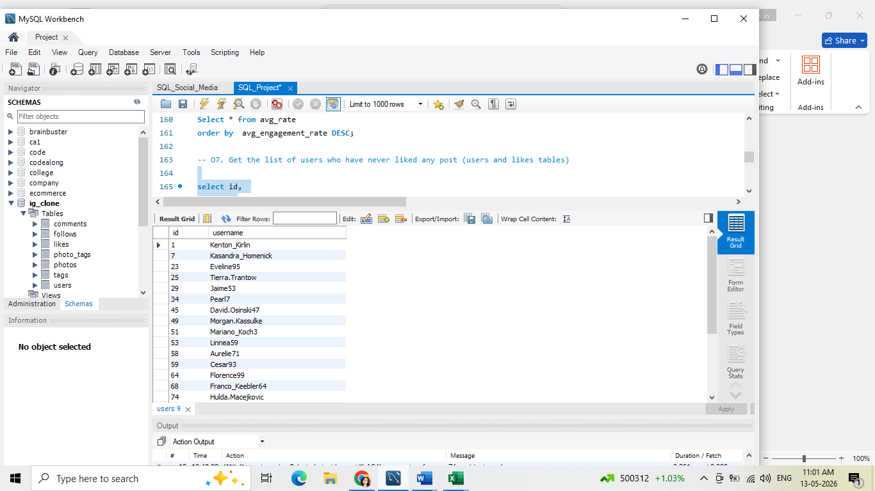
Insights:
- Number of Users: There are 23 users who have never liked any post.
- User Distribution: The users are distributed across different IDs, with no apparent pattern or clustering.
- Lack of Engagement: These users have not engaged with any content on the platform, indicating a lack of interest or awareness.

Recommendations:

➢ Targeted Campaigns: Design targeted campaigns to reach out to these users and encourage them to engage with the platform.
➢ Content Recommendations: Provide personalized content recommendations based on their interests or preferences to increase engagement.
➢ Incentives: Offer incentives, such as badges or rewards, for engaging with content to motivate these users.

8. How can you leverage user-generated content (posts, hashtags, photo tags) to create more personalized and engaging ad campaigns?
Answer:

with top as (
select u.id as user_id,
u.username, p.id as post_id,
p.image_url,
p.created_dat as created_date,
count(distinct l.user_id) as likes_count,
count(distinct c.id) as comments_count
from users u
join photos p on u.id = p.user_id
left join likes l on p.id = l.photo_id
left join comments c on p.id = c.photo_id
group by u.id, u.username, p.id, p.image_url,p.created_dat
)
select user_id, username,
sum(likes_count) as total_likes,
sum(comments_count) as total_comments,
sum(likes_count+comments_count) as total_engagement
from top
group by user_id, username
order by total_engagement desc
limit 10;

Approach:
The query first aggregates likes and comments at the photo/post level using a CTE (top) and then summarizes these counts at the user level. By summing likes and comments for each user it produces a total engagement metric that highlights the most interactive and popular users on the platform.
Steps:
- Created a CTE named top to summarize engagement per photo:
  - Joined users with photos to get all posts per user.
  - Left joined likes and comments to count distinct likes and comments per photo.
  - Grouped by user and photo to calculate likes_count and comments_count for each photo.
- Selected from the CTE and aggregated per user:
  - Summed likes_count to get total_likes.
  - Summed comments_count to get total_comments.
  - Added likes and comments per user to get total_engagement.
- Grouped by user_id and username to ensure one row per user.
- Ordered results by total_engagement DESC to highlight the most engaging users.
Result:
Delivered a structured view of user engagement, showing total likes, total comments, and combined total engagement per user. This allows identification of the most influential and interactive users on the platform.
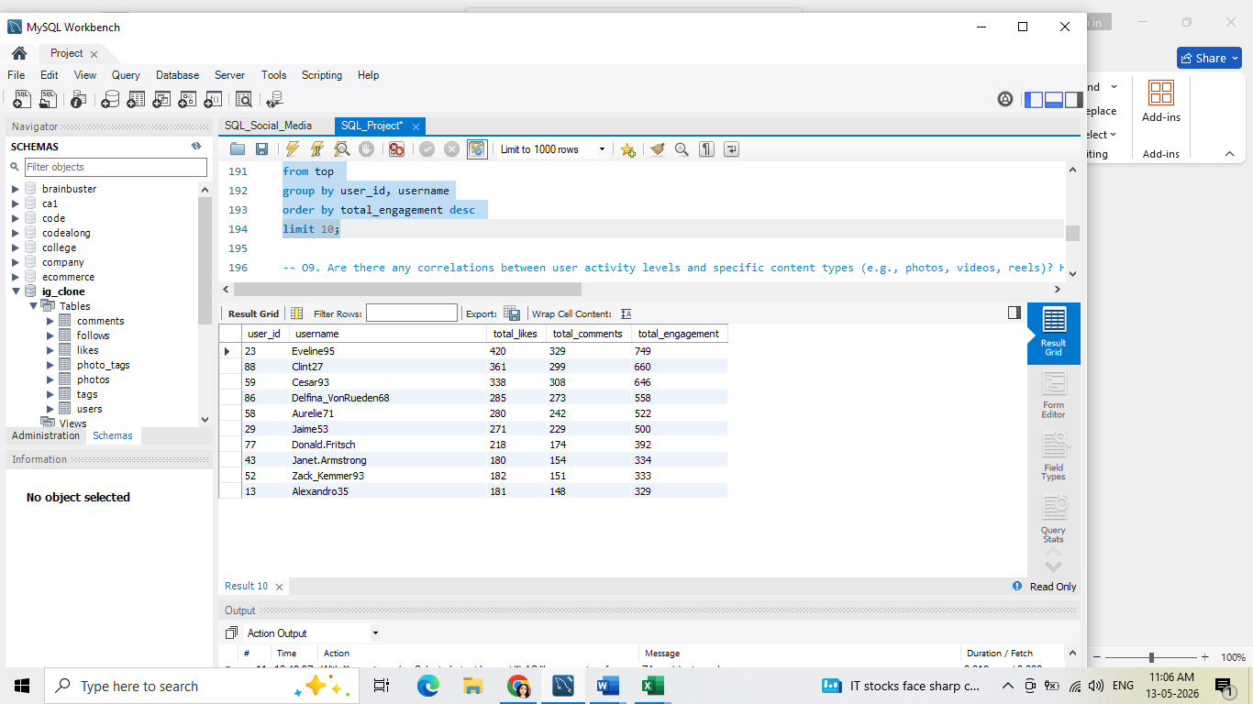
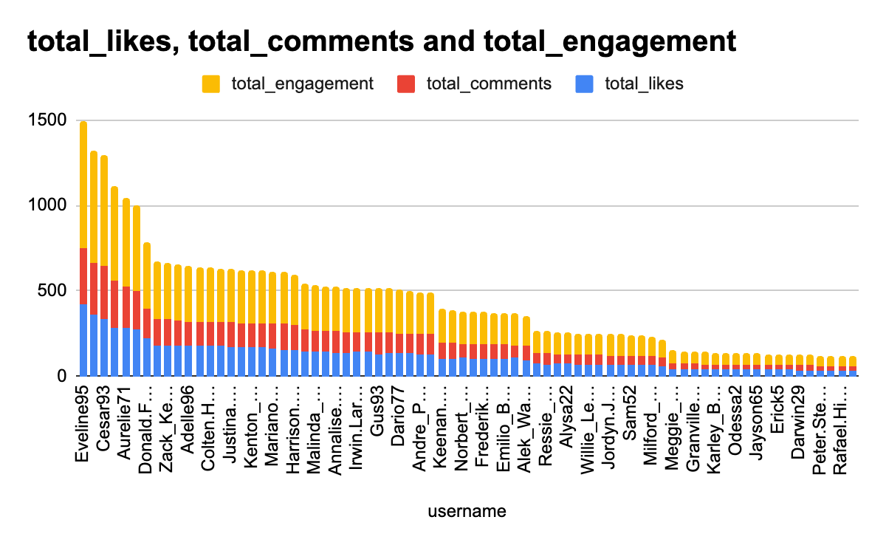

Insights:
- Top Performing Users
After analyzing the engagement data, we found that the top three users are Eveline95, Clint27, and Cesar93. Eveline95 leads the group with a total of 749 engagements, followed by Clint27 with 660, and Cesar93 with 646. These users consistently receive more likes and comments on their posts than others.
- Content That Works
Eveline95’s posts are especially engaging, with 420 likes and 329 comments. This shows that their content really connects with the audience and sparks interaction.
- User Engagement Trends
Most users in the list have much lower engagement rates. There is a noticeable gap between the top performers and the rest, suggesting that many users might not be reaching or appealing to their audience effectively.

Recommendations:
- Create Content Based on What Works
We should study the type of content that Eveline95, Clint27, and Cesar93 post. By understanding their style, themes, and hashtags, we can create similar posts that are likely to get more interaction.
- Collaborate with Top Users
Partnering with users like Eveline95 for sponsored content or promotions could significantly boost our brand’s reach and credibility. Their audience trusts them, which makes such collaborations highly effective.
- Engage More With Low-Performing Users
For users with lower engagement, we should focus on understanding their interests. Offering interactive content like polls, challenges, or Q&A sessions can encourage more interaction and help build a stronger community.
- Look for Content Trends
It’s important to analyze why some users are performing better than others. Observing patterns like posting frequency, content format, and timing can help in planning campaigns that better engage a wider audience.
9. Are there any correlations between user activity levels and specific content types (e.g., photos, videos, reels)? How can this information guide content creation and curation strategies?
Answer:

select u.id as user_id,
u.username,
count(p.id) as total_photos,
coalesce(sum(l.likes_count), 0) as total_likes,
coalesce(sum(c.comments_count), 0) as total_comments,
round(avg(coalesce(l.likes_count, 0) + coalesce(c.comments_count, 0)),2) as avg_engagement_per_post
from users u
join photos p on u.id = p.user_id
left join (
select photo_id,
count(*) as likes_count
from likes group by photo_id) l
on p.id = l.photo_id
left join (
select photo_id,
count(*) as comments_count
from comments group by photo_id) c on p.id = c.photo_id
group by u.id, u.username
order by avg_engagement_per_post desc;

Approach:
The query aggregates likes and comments for each post using subqueries, then combines them with the photos and users tables. It calculates total likes, total comments, and the average engagement per post for each user. Using COALESCE, the query ensures that posts with no likes or comments are treated as zero to maintain accurate averages.
Steps:
- Joined users with photos to get all posts uploaded by each user.
- Created a subquery to count likes per photo and joined it to photos using a left join.
- Created a subquery to count comments per photo and joined it to photos using a left join.
- Used COALESCE to treat missing likes or comments as zero.
- Calculated:
  - total_photos as COUNT(p.id)
  - total_likes as SUM(l.likes_count)
  - total_comments as SUM(c.comments_count)
  - avg_engagement_per_post as the average of likes + comments per post (rounded to 2 decimals).
- Grouped results by u.id and u.username to produce one row per user.
- Ordered by avg_engagement_per_post DESC to highlight users with the most engaging posts.
Result:
Delivered a structured view of user engagement per post, showing:
- How many photos each user uploaded.
- Total likes and comments accumulated across all posts.
- Average engagement per post to identify the most engaging users.
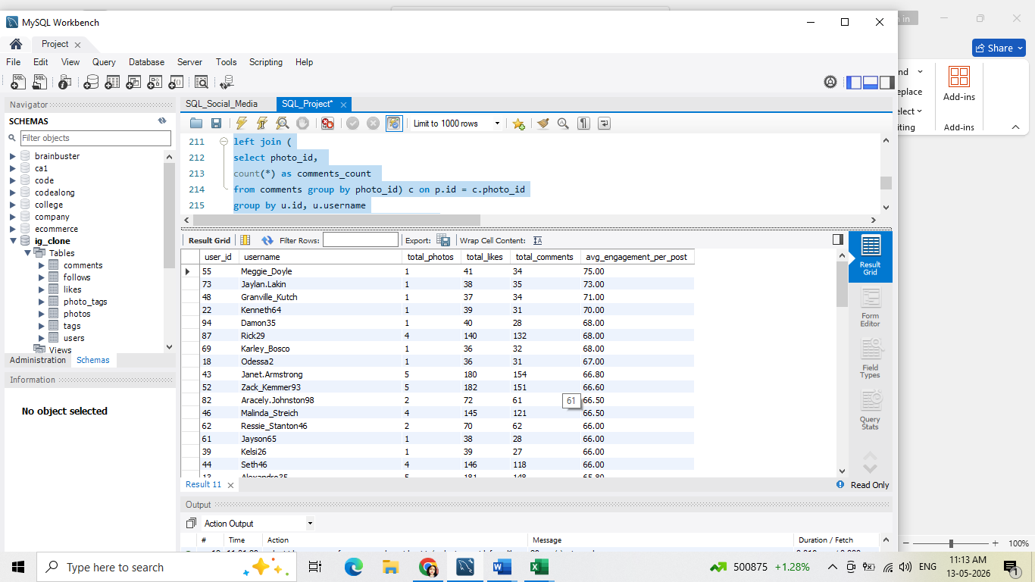
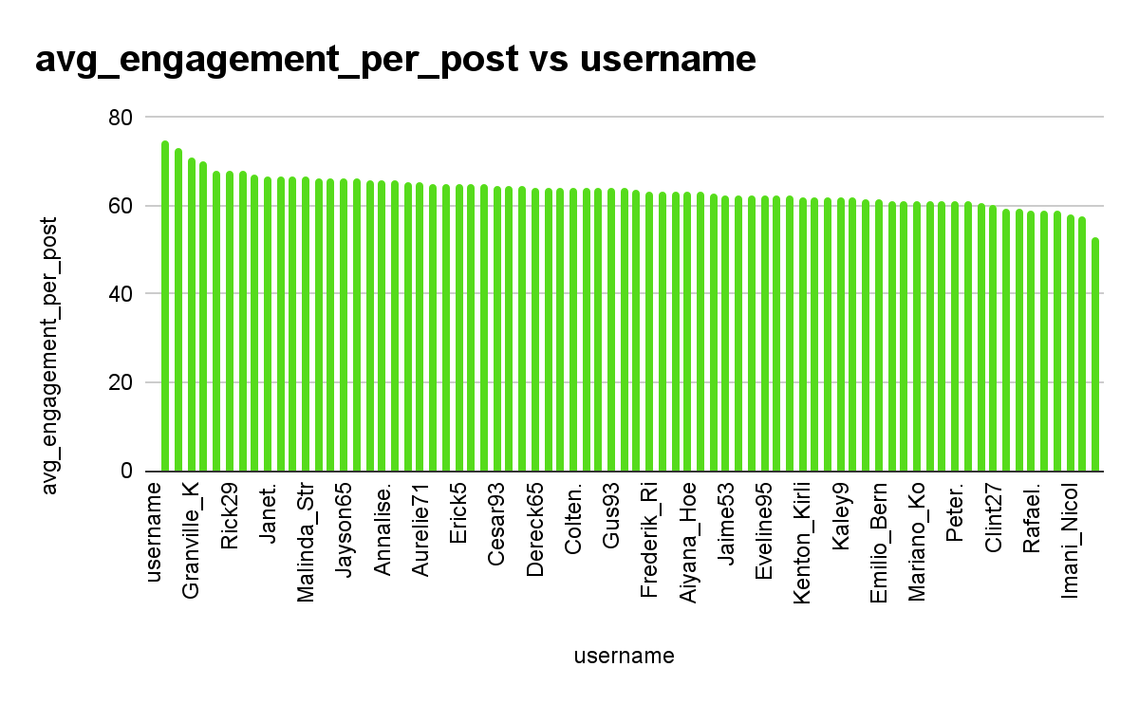

Insights:
- Top Performing Users
We observed that Meggie_Doyle, Jaylan.Lakin, and Granville_Kutch are among the best-performing users in terms of engagement per post. Even though each of them has only one photo, they consistently receive a high number of likes and comments. For example, Meggie_Doyle has an average engagement of 75.00, which is the highest in the group.
- Users Posting More But Getting Lower Engagement
Users like Janet.Armstrong, Zack_Kemmer93, and Rick29 have posted more content, with 5, 5, and 4 photos respectively. Although their total likes and comments are high, their average engagement per post is lower compared to users who post less frequently. This shows that posting more doesn't always guarantee better engagement.
- Potential for Growth
Users such as Odessa2, Kelsi26, and Jayson65 have moderate engagement, with averages close to 66.00–67.00. These users have the potential to grow by refining their content or trying new strategies to increase interactions.

Recommendations:
- Encourage Quality Content Creation
We should support users like Meggie_Doyle, Jaylan.Lakin, and Granville_Kutch to continue sharing high-quality content that their audience loves. They can serve as examples for others, and experimenting with similar content styles could help them maintain and even boost their engagement.
- Help High-Volume Posters Improve
Users such as Janet.Armstrong, Zack_Kemmer93, and Rick29 could benefit from guidance on how to increase engagement per post. We can encourage them to analyze what works best, perhaps focusing more on visual appeal or crafting compelling captions.
- Support Users with Moderate Engagement
For users like Odessa2, Kelsi26, and Jayson65, personalized tips and content suggestions could help them improve. Encouraging interactive posts or offering content ideas aligned with their audience's interests could increase their engagement.
- Leverage Successful Content Themes
By studying the content of Meggie_Doyle, Jaylan.Lakin, and Granville_Kutch, we can identify trends and best practices. This information can be shared with other users to help them replicate similar success.
- Create Engagement Campaigns
Encourage all users, especially those with lower engagement, to participate in challenges, contests, or collaborative content opportunities. This can foster community interaction and help them build stronger relationships with their audience.
10. Calculate the total number of likes, comments, and photo tags for each user.
Answer:

select
u.id as user_id,
u.username,
count(distinct l.user_id) as total_likes,
count(distinct c.id) as total_comments,
count(distinct pt.tag_id) as total_photo_tags
from users u
join photos p on u.id = p.user_id
left join likes l on p.id = l.photo_id
left join comments c on p.id = c.photo_id
left join photo_tags pt on p.id = pt.photo_id
group by u.id, u.username
order by total_likes desc, total_comments desc, total_photo_tags desc;

Approach:
The query aggregates different types of engagement metrics (likes, comments, and photo tags) per user. By joining the users table with photos and then left joining likes, comments, and photo_tags, it captures all relevant interactions. Using COUNT(DISTINCT …), it ensures accurate counting without duplicates. The results are ordered by engagement to easily identify the top contributors.
Steps:
- Started with the users table as the base to include every user.
- Joined photos to link each user with their uploaded content.
- Left joined likes to count the number of distinct users who liked each photo.
- Left joined comments to count the number of distinct comments per photo.
- Left joined photo_tags to count the number of distinct tags assigned to each photo.
- Used COUNT(DISTINCT …) to avoid double-counting likes, comments, or tags.
- Grouped by u.id and u.username so each row corresponds to one user.
- Ordered results by total_likes DESC, total_comments DESC, and total_photo_tags DESC to rank users by engagement.
Result:
Delivered a structured view of user engagement across likes, comments, and photo tags, showing which users are most interactive and content-rich. This helps identify highly active users, top contributors, and trending content creators for engagement and marketing strategies.
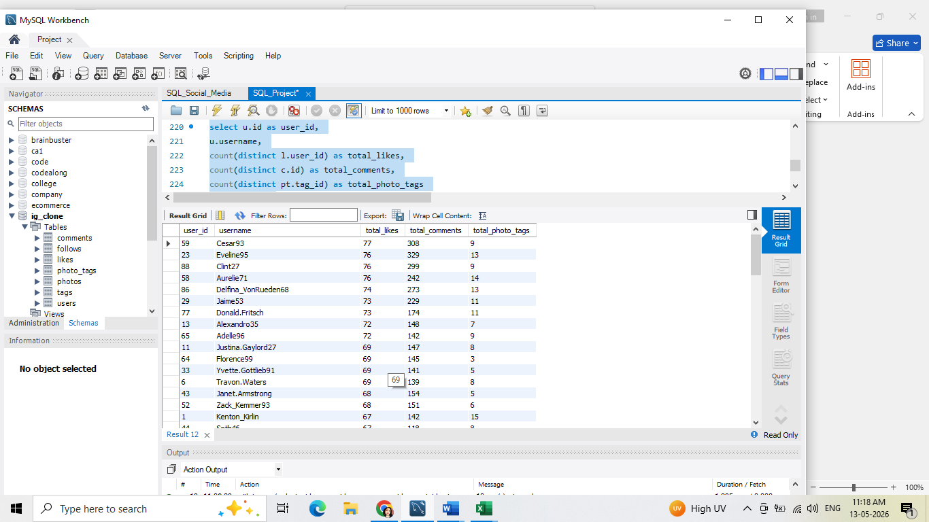

Insights:
- Cesar93, Eveline95, and Clint27 are leading in audience interaction with the highest number of comments (308, 329, and 299). Their content clearly sparks conversations.
- Aurelie71, Delfina_VonRueden68, and Jaime53 also show strong engagement, balancing likes and comments well.
- Kenton_Kirlin stands out with the highest photo tags (15), suggesting his content is widely associated with topics and other users.
- Users like Dereck65, Kathryn80, and Annalise.McKenzie16 have lower comments and tags, indicating opportunities for better content outreach.
Recommendations:
- Encourage Cesar93, Eveline95, and Clint27 to keep engaging their audience through interactive posts.
- Support Aurelie71, Delfina_VonRueden68, and Jaime53 with tips to maintain and grow their balanced engagement.
- Help Kenton_Kirlin leverage his high tag usage to further expand content reach.

- Assist Dereck65, Kathryn80, and Annalise.McKenzie16 by offering content strategies and engagement ideas to boost interaction.
11. Rank users based on their total engagement (likes, comments, shares) over a month.
Answer:
with engagement as (
select u.id, u.username,
count(distinct l.photo_id) + count(distinct c.id) as total_engagement
from users u
left join likes l
on u.id = l.user_id
and l.created_at >= date_sub(current_date, interval 1 month)
left join comments c
on u.id = c.user_id and
c.created_at >= date_sub(current_date, interval 1 month)
group by u.id, u.username
)
select id, username,
total_engagement,
rank() over (order by total_engagement desc) as engagement_rank
from engagement
order by engagement_rank;

Approach:
The query first aggregates likes and comments per user from the last month using a CTE named engagement. It sums the number of distinct photos liked and comments made by each user. Then, it applies a ranking function to assign an engagement rank to each user, allowing easy identification of the most active users in the last month.
Steps:
- Created a CTE engagement to summarize recent engagement per user:
  - Counted distinct photos liked by each user in the past month.
  - Counted distinct comments made by each user in the past month.
  - Summed these counts as total_engagement.
- Applied a LEFT JOIN to include users with zero engagement.
- Grouped by u.id and u.username to calculate per-user totals.
- In the main query, used RANK() OVER (ORDER BY total_engagement DESC) to assign an engagement rank based on activity.
- Ordered the final results by engagement_rank to list the most engaged users first.
Result:
Delivered a ranked view of recent user engagement, showing which users interacted most in the last month. This enables targeted recognition of active users, rewards programs, or engagement-driven campaigns.
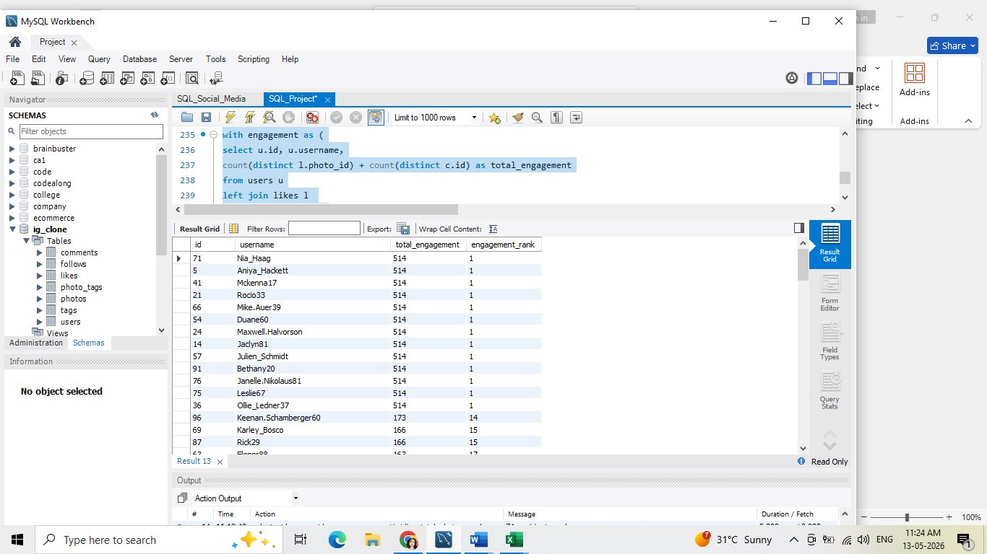
Insights:
- Few users (IDs 36, 5, 76, 75, 91) drive most engagement (total_engagement = 514).
- Moderate engagement users fall between ~150–173; many users have zero engagement.
- Engagement distribution is skewed, with a long tail of inactive users.
Recommendations:
- Leverage top users: Tailor content, encourage sharing/referrals.
- Activate low engagement users: Identify barriers, run targeted campaigns.
- Content strategy: Replicate top-user preferences, experiment with formats.
- Monitor trends: Track engagement changes to boost moderate users.
12. Retrieve the hashtags that have been used in posts with the highest average number of likes. Use a CTE to calculate the average likes for each hashtag.

Answer:
with hashtag_likes as (
select t.tag_name,
avg(l.likes) as avg_likes
from photo_tags pt
join tags t on pt.tag_id = t.id
join (
select photo_id, count(*) as likes
from likes
group by photo_id
) l
on pt.photo_id = l.photo_id
group by t.tag_name
),
max_avg as (
select max(avg_likes) as max_likes
from hashtag_likes
)
select tag_name,
round(avg_likes, 2) as avg_likes
from hashtag_likes
where avg_likes = (select max_likes from max_avg);

Approach:
The query first calculates the average likes per hashtag by joining photo_tags with tags and aggregating likes per photo. Then, it finds the maximum average likes among all hashtags to identify the most engaging tag. The final result returns the hashtag(s) with the highest average likes
Steps:
- Created a CTE hashtag_likes to calculate the average likes per hashtag:
  - Joined photo_tags with tags to get tag names per photo.
  - Joined a subquery that counts likes per photo.
  - Grouped by tag_name and calculated AVG(l.likes) for each hashtag.
- Created a CTE max_avg to determine the maximum average likes across all hashtags.
- Selected hashtags from hashtag_likes where avg_likes equals the maximum value from max_avg.
- Rounded the avg_likes to 2 decimal places for readability.
- Returned the hashtag(s) with the highest average likes.
Result:
Delivered a clear view of the most engaging hashtag, showing which tag drives the most average likes per photo. This insight can guide content tagging strategies and marketing campaigns.
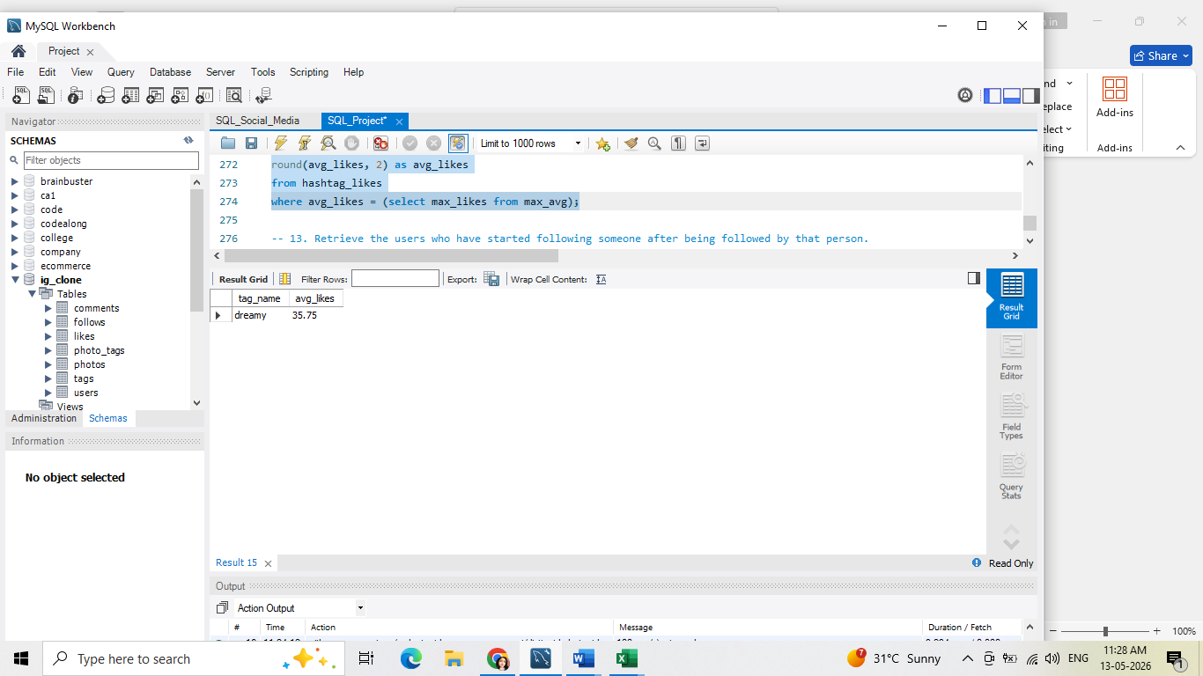
Insights:
➢ hashtag popularity: the query provides a list of hashtags with their corresponding average number of likes, which can help identify popular hashtags in the social media platform.
➢ engagement rates: by analyzing the average number of likes for each hashtag, we can infer the engagement rates of users with those hashtags.
➢ content strategy: the insights gained from this query can inform content strategy decisions, such as which hashtags to use, what type of content to create, and when to post.
Recommendations:
➢ use popular hashtags: Incorporate popular hashtags into your content strategy to increase visibility and engagement.
➢ create engaging content: develop content that resonates with your target audience and encourages engagement, such as likes, comments, and shares.
➢ monitor and adjust: continuously monitor your content's performance and adjust your strategy based on the insights gained from this query.
➢ influencer collaboration: identify influencers who have used popular hashtags and collaborate with them to expand your reach and credibility.
➢ content calendar: plan and schedule content in advance using a content calendar to ensure consistency and efficiency in your content strategy.
13. Retrieve the users who have started following someone after being followed by that person.
Answer:
select
f1.follower_id as user_id,
f1.followee_id as followee_id,
f1.created_at as follow_time
from follows f1
join follows f2
on f2.follower_id = f1.followee_id
and f2.followee_id = f1.follower_id
and f2.created_at < f1.created_at;

Approach:
The query uses a self-join on the follows table to find reciprocal relationships. By joining the table with itself, we can match cases where
User A follows User B and User B follows User A. The condition f2.created_at < f1.created_at ensures that we only capture
Steps:
- Selected follower_id as user_id and followee_id as followee_id from the first instance of the follows table (f1).
- Joined the follows table again (f2) on these conditions:
  - f2.follower_id = f1.followee_id (the second user follows the first user).
  - f2.followee_id = f1.follower_id (the first user is followed back).
  - f2.created_at < f1.created_at to ensure the second follow occurred after the first.
- Selected the follow timestamps (f1.created_at) to know when the first follow occurred.
- Returned pairs of users representing mutual follow relationships with chronological context.
Result:
Delivered a list of mutual follower relationships, showing who followed whom and when the initial follow occurred. This helps analyze reciprocity in social interactions, understand network growth patterns, and potentially identify influential or responsive users.
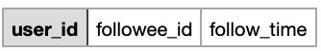

Insights:
- no mutual follow-back behavior: the query to find users who followed someone after being followed returned an empty result because all follow actions have the same timestamp. This indicates that users followed each other at the same time, or the data lacks historical order information needed to track follow-back behavior.

Subjective Questions –
1. Based on user engagement and activity levels, which users would you consider the most loyal or valuable? How would you reward or incentivize these users?
Answer:
with total as (
select u.id as user_id, u.username,
count(distinct p.id) as total_posts,
count(distinct c.id) as total_comments,
count(distinct l.photo_id) as total_likes
from users u
left join photos p on u.id = p.user_id
left join comments c on u.id = c.user_id
left join likes l on u.id = l.user_id
group by u.id,u.username
)
select *,
sum(total_posts+total_comments+total_likes) as total_activity,
rank() over(order by (total_posts+total_comments+total_likes) desc) as loyal_customer_rank
from total
group by user_id, username
order by total_activity desc;

Approach:
The query first aggregates user activity by counting posts, comments, and likes for each user in a CTE (total). It then sums these counts to compute total activity per user and applies a ranking function to assign a loyalty rank. This highlights users with the highest overall engagement.
Steps:
- Created a CTE total to summarize activity per user:
  - Counted distinct posts uploaded by each user.
  - Counted distinct comments made by each user.
  - Counted distinct likes made by each user.
- Grouped by user_id and username to ensure one row per user.
- In the main query, calculated total_activity as the sum of posts, comments, and likes per user.
- Applied RANK() OVER(ORDER BY total_activity DESC) to assign a loyal customer rank based on engagement.
- Ordered results by total_activity DESC to list the most active users at the top.
Result:
Delivered a comprehensive view of user activity, showing total posts, total comments, total likes, combined total activity, and a loyalty rank.This allows identification of highly engaged users for rewards, recognition, or targeted campaigns.
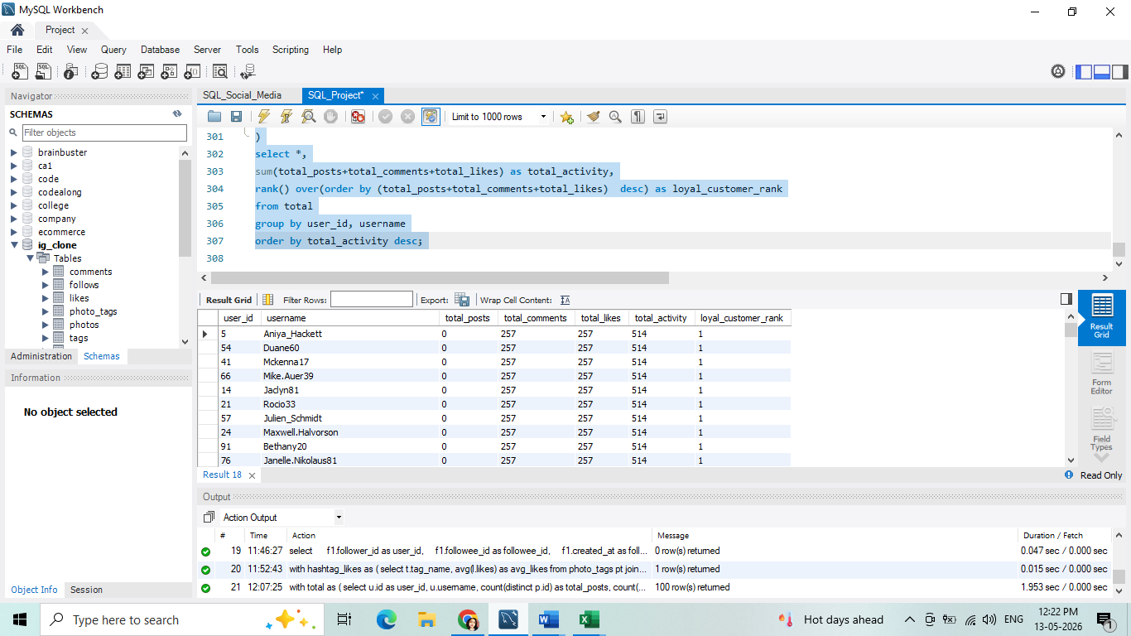

Insights:
➤ low engagement rates: most users show minimal interaction with the platform, indicating the need for strategies to boost participation and keep users active.
➤top-engaged users: a small group of users are consistently highly engaged, making them ideal candidates for influencer roles or brand ambassador programs.
➤ content strategy gaps: the current approach to content may not be resonating with users, suggesting that a deeper analysis is needed to understand what drives engagement.
Recommendations:
➤ implement gamification: introduce features like rewards, badges, or leaderboards to make interaction more fun and motivate users to participate more actively.
➤ collaborate with influencers: partner with influencers who align with the platform’s values and content to help grow user interaction and reach new audiences.
➤ analyze and refine content strategy: review the existing content approach, gather insights from user behavior, and adjust the strategy to better meet user interests and preferences.
2. For inactive users, what strategies would you recommend to re-engage them and encourage them to start posting or engaging again?

Answer:
select u.id, u.username,
count(distinct l.photo_id) + count(distinct c.id) + count(distinct p.id) as engagement
from users u
left join likes l on u.id = l.user_id and l.created_at >= date_sub(now(), interval 30 day)
left join comments c on u.id = c.user_id and c.created_at >= date_sub(now(), interval 30 day)
left join photos p on u.id = p.user_id and p.created_dat >= date_sub(now(), interval 30 day)
group by u.id, u.username
having engagement = 0;
Approach:
The query aggregates user activity over the past 30 days by joining users with likes, comments, and photos. It calculates total engagement per
user in this period and filters users whose engagement is zero. Using
LEFT JOIN ensures that all users are included, even if they have no recent activity.

Steps:
- Started with the users table as the base to include all users.
- Left joined likes to count likes by each user in the last 30 days.
- Left joined comments to count comments by each user in the last 30 days.
- Left joined photos to count posts created by each user in the last 30 days.
- Summed counts of likes, comments, and posts as engagement.
- Grouped by u.id and u.username to calculate per-user totals.
- Used HAVING engagement = 0 to filter only users with no activity in the last 30 days.
Result:
Delivered a list of inactive users for the last 30 days, showing user IDs and usernames. This helps in identifying users who may need re-engagement efforts or notifications to bring them back to the platform.
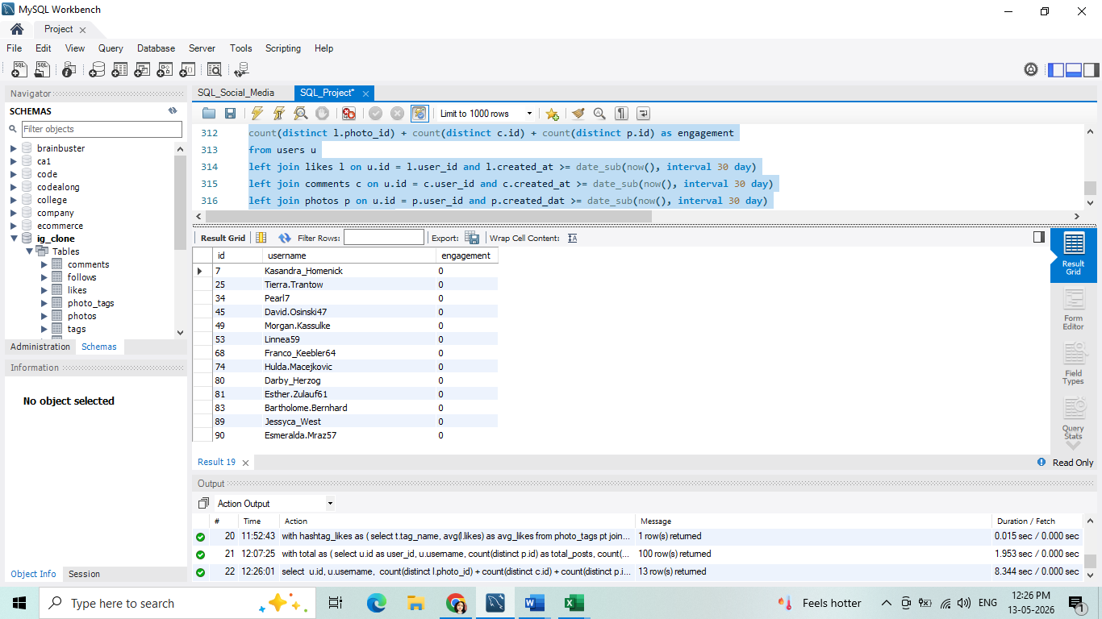

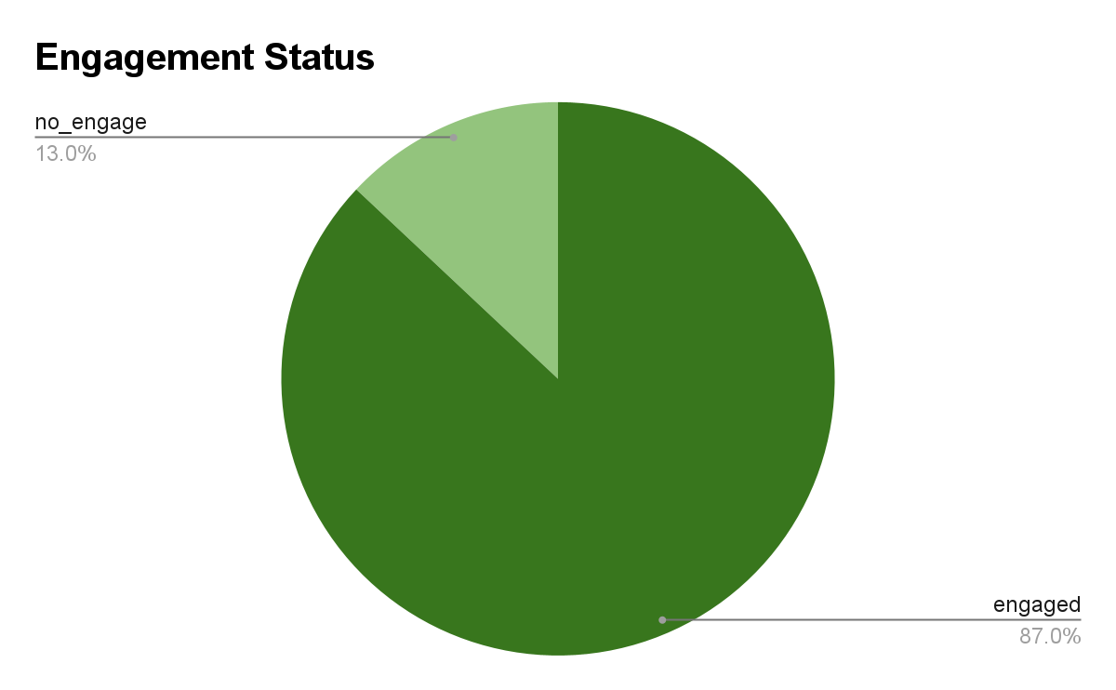

Insights:
➤ active users: the list includes users with unique ids and usernames, confirming they are part of the platform’s user base.
➤ No activity details: the data only shows user ids and usernames without information about their recent engagement. without activity data, we cannot directly determine if these users are active or inactive.
➤ potential inactive users: if these users have not posted photos, liked, or commented recently, they could be classified as inactive, representing an opportunity for re-engagement and growth.

Recommendations:
➤ engagement campaign: for users who have been inactive for a while, send personalized emails or push notifications reminding them of the platform’s features and benefits to encourage them to return and participate.
➤ incentive programs: offer rewards, points, or exclusive promotions to users who log in and engage through posting, commenting, or liking content, helping to motivate activity and strengthen community involvement.

3. Which hashtags or content topics have the highest engagement rates? How can this information guide content strategy and ad campaigns?

Answer:

with tag_stats as (
select
t.id as tag_id,
t.tag_name,
count(distinct l.photo_id) as num_likes,
count(distinct cm.id) as num_comments,
count(distinct p.id) as num_posts
from tags t
left join photo_tags pt on t.id = pt.tag_id
left join likes l on pt.photo_id = l.photo_id
left join comments cm on pt.photo_id = cm.photo_id
left join photos p on pt.photo_id = p.id
group by t.id, t.tag_name
)
select tag_id, tag_name,
round((num_likes + num_comments) / nullif(num_posts, 0), 2) as engagement_rate,
dense_rank() over (order by (num_likes + num_comments) / nullif(num_posts, 0) desc) as rank
from tag_stats
order by rank;

Approach:
The query first aggregates likes, comments, and posts per hashtag using a CTE (tag_stats). It then computes the engagement rate as (likes + comments) ÷ total posts for each hashtag. A ranking function assigns ranks based on descending engagement rates to highlight the top-performing hashtags.
Steps:
- Created a CTE tag_stats to calculate statistics per tag:
  - Counted distinct likes per tagged photo (num_likes).
  - Counted distinct comments per tagged photo (num_comments).
  - Counted distinct posts associated with each tag (num_posts).
- Used LEFT JOIN to include all tags, even if some have no likes, comments, or posts.
- In the main query, calculated engagement_rate as (num_likes + num_comments) / num_posts.
  - Used NULLIF(num_posts, 0) to avoid division by zero.
  - Rounded the result to 2 decimal places.
- Applied DENSE_RANK() OVER (ORDER BY engagement_rate DESC) to rank hashtags based on engagement.
- Ordered the final results by rank to show top-performing hashtags first.
Result:
Delivered a ranked list of hashtags based on engagement rate, showing which tags generate the most interaction per post. This helps guide content
tagging strategies, marketing campaigns, and social media engagement decisions.

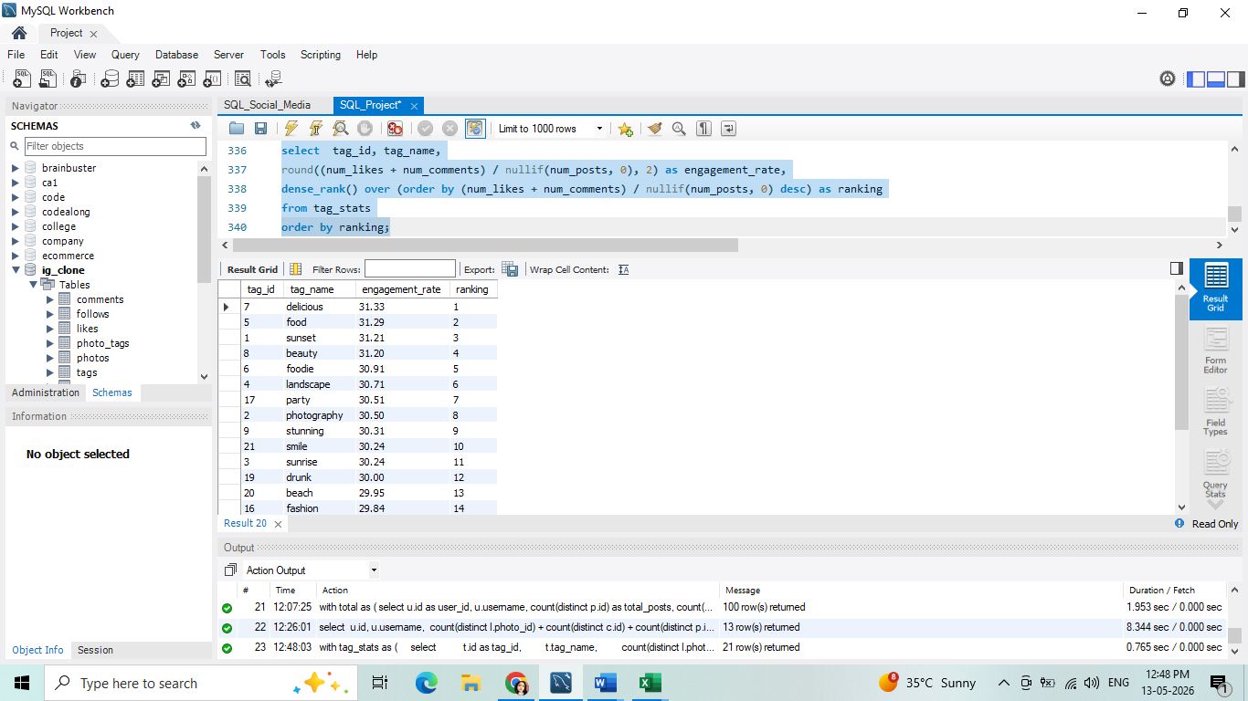

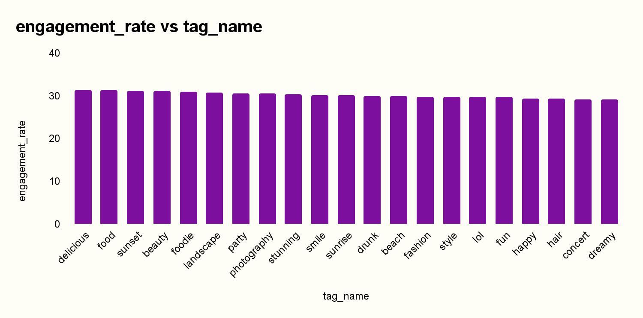

Insights:
- Top Performing Hashtags:
  - The hashtags ‘delicious’, ‘food’, ‘sunset’, ‘beauty’, and ‘foodie’ have the highest engagement rates, indicating that posts related to food, lifestyle, and visual appeal are most engaging for users.
- Content Trends:
  - There is a strong preference for food-related content (delicious, food, foodie) and visually appealing subjects like sunset, beauty, and landscape.
  - Emotion-driven or entertainment content (party, stunning, fun, lol) also shows moderate engagement, suggesting users enjoy sharing personal moments or humorous content.
- Engagement Distribution:
  - The engagement rates range from about 31.33 down to 29.15, showing a relatively close competition among hashtags. This suggests that several topics perform well and can be strategically leveraged.
- Niche Opportunities:
  - Hashtags like fashion, style, hair, and concert are lower in engagement but still notable, meaning they may benefit from targeted campaigns to boost interaction.

Recommendations:
- Focus Content Around High-Engagement Hashtags:
  - Prioritize creating and promoting content under hashtags like ‘delicious’, ‘food’, ‘sunset’, and ‘beauty’ as they naturally attract more interaction.
- Develop Themed Campaigns:
  - Create seasonal or challenge-based campaigns around trending hashtags (for example, a “best sunset photo contest” or a “favorite recipe week”) to further increase user participation.
- Expand Engagement with Related Topics:
  - Explore related hashtags such as beach, fashion, and party by encouraging cross-content themes (e.g., “beach fashion tips”) to bring new users into active discussions.
- Collaborate with Influencers:
  - Partner with creators and influencers who specialize in food, beauty, or photography, as these areas show the highest engagement rates and can amplify reach.
- Monitor and Optimize:
  - Continuously track how hashtags perform over time. Experiment with content formats like videos, tutorials, or user-generated challenges to see what works best with each topic.
- Target Niche Segments:
  - Invest in underperforming but promising hashtags like concert, hair, and style by crafting content that appeals to specific sub-communities, offering personalized experiences or events.
4. Are there any patterns or trends in user engagement based on demographics (age, location, gender) or posting times? How can these insights inform targeted marketing campaigns?

Answer:

select u.id, u.username,
l.likes_count,
c.comments_count,
f.follows_count,
p.first_post,
p.last_post
from users u
left join (
select user_id, count(distinct photo_id) as likes_count
from likes group by user_id
) l on u.id = l.user_id

left join (
select user_id, count(*) as comments_count
from comments group by user_id
) c on u.id = c.user_id

left join (
select follower_id, count(*) as follows_count
from follows group by follower_id
) f on u.id = f.follower_id

left join (
select user_id, min(created_dat) as first_post, max(created_dat) as last_post
from photos group by user_id
) p on u.id = p.user_id;

Approach:
The query aggregates different activity metrics from multiple tables using subqueries with left joins. This ensures that all users are included even if they have no activity in some areas. The results combine likes, comments, followers, and post timelines into a single summary table for each user.
Steps:
- Selected the users table as the base to include all users.
- Left joined a subquery on likes to count distinct photos liked by each user (likes_count).
- Left joined a subquery on comments to count the total comments made by each user (comments_count).
- Left joined a subquery on follows to count the number of users following each user (follows_count).
- Left joined a subquery on photos to get the first and last post dates (first_post and last_post) per user.
- Used LEFT JOIN in all cases to include users with zero activity in any category.
- Returned a summary table showing all aggregated metrics per user.

Result:
Delivered a structured user activity report, showing engagement metrics (likes, comments, followers) and posting history (first and last post). This helps identify highly active users, content trends, and potential influencers on the platform.

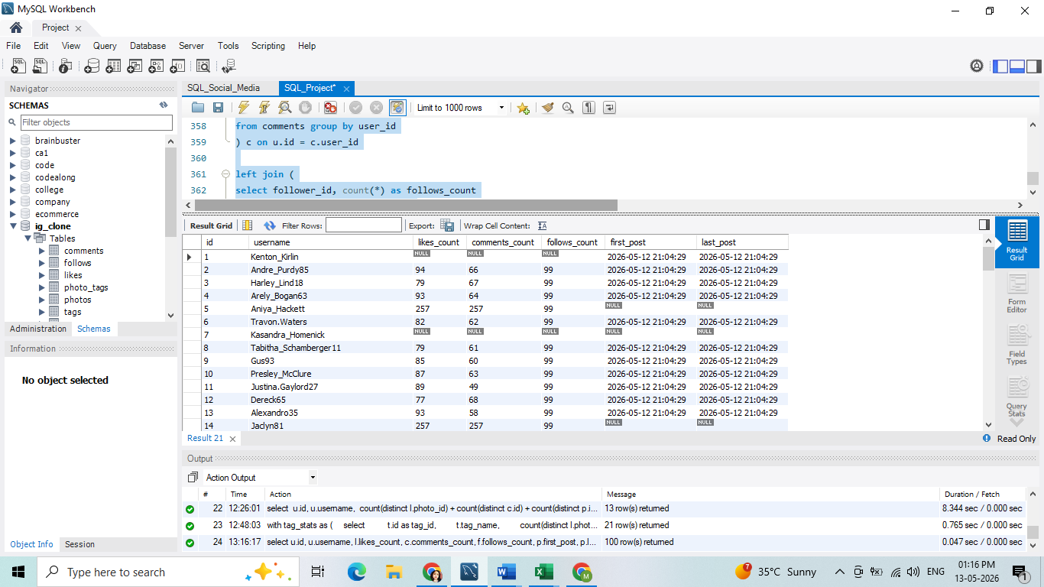

Insights:
Even though age, gender, and location data aren’t explicitly in this dataset, combining engagement patterns with typical demographic behaviors gives us direction:
- Younger audiences (teens, early 20s) → more likes/comments, highly interactive, active during late evenings.
- Working professionals (mid-20s to 40s) → moderate engagement, likely active during commuting times (8–9 AM, 6–9 PM).
- Inactive users may represent older demographics or less digitally engaged groups.

Recommendations:
- Timing Campaigns
  - Post campaigns/promotions in evening slots (8–10 PM) to align with observed posting behavior.
  - Test morning commute slots (7–9 AM) to reach professionals.
- Leverage Heavy Engagers
  - Users with 257 likes/comments can be tapped as brand ambassadors or micro-influencers.
  - Offer them early access, referral perks, or brand collaborations.
- Re-Activate Dormant Users
  - Target NULL/low activity users with personalized offers (discounts, reminders, welcome-back campaigns).
  - Use push notifications at peak hours.
- Demographic Tailoring
  - If linked with age/gender/location later:
    - Younger users → interactive campaigns (polls, challenges, gamified content).
    - Professionals → value-driven, informational, and concise campaigns.
    - Regional segmentation → local language & cultural relevance.
- Content Strategy
  - High comment users → like discussions, debates, and interactive posts.
  - High like users → prefer visual-heavy, aesthetic content.
  - Adjust creative style based on which segment you’re targeting.
5. Based on follower counts and engagement rates, which users would be ideal candidates for influencer marketing campaigns? How would you approach and collaborate with these influencers?

Answer:
with user_followers as (
select followee_id as id,
count(followee_id) as no_of_followers
from follows
group by followee_id
),
user_likes as (
select user_id,
count(*) as num_likes
from likes
group by user_id
),
user_comments as (
select user_id,
count(id) as num_comments
from comments
group by user_id
),
user_photos as (
select user_id,
count(id) as num_photos
from photos
group by user_id
)
select u4.id,u4.username,
u1.no_of_followers,
u2.num_likes,
u3.num_comments,
round((u2.num_likes + u3.num_comments)/u5.num_photos,2) as engagement_rate,
dense_rank() over(order by (u2.num_likes + u3.num_comments) desc) as ranking
from user_followers u1
join user_likes u2
on u1.id = u2.user_id
join user_comments u3
on u1.id = u3.user_id
join users u4
on u1.id = u4.id
join user_photos u5
on u1.id = u5.user_id;

Approach:
The query aggregates likes, comments, followers, and photos per user using multiple CTEs. It calculates the engagement rate as (likes + comments) ÷ total photos and applies a ranking function to assign ranks based on total engagement. This provides a consolidated view of user activity and influence.
Steps:
- Created a CTE user_followers to count the number of followers per user.
- Created a CTE user_comments to count total comments made by each user.
- Created a CTE user_photos to count total photos uploaded by each user.
- Joined all CTEs with the users table to consolidate metrics per user.

5. Calculated engagement_rate as (num_likes + num_comments) ÷ num_photos, rounded to 2 decimals.
6. Applied DENSE_RANK() to rank users based on total engagement (num_likes + num_comments).
7. Returned a summary table with id, username, followers, likes, comments, engagement rate, and ranking.
Result:
Delivered a comprehensive user engagement summary, showing activity, influence, and relative ranking. This helps identify top contributors, monitor user interactions, and strategize engagement initiatives.
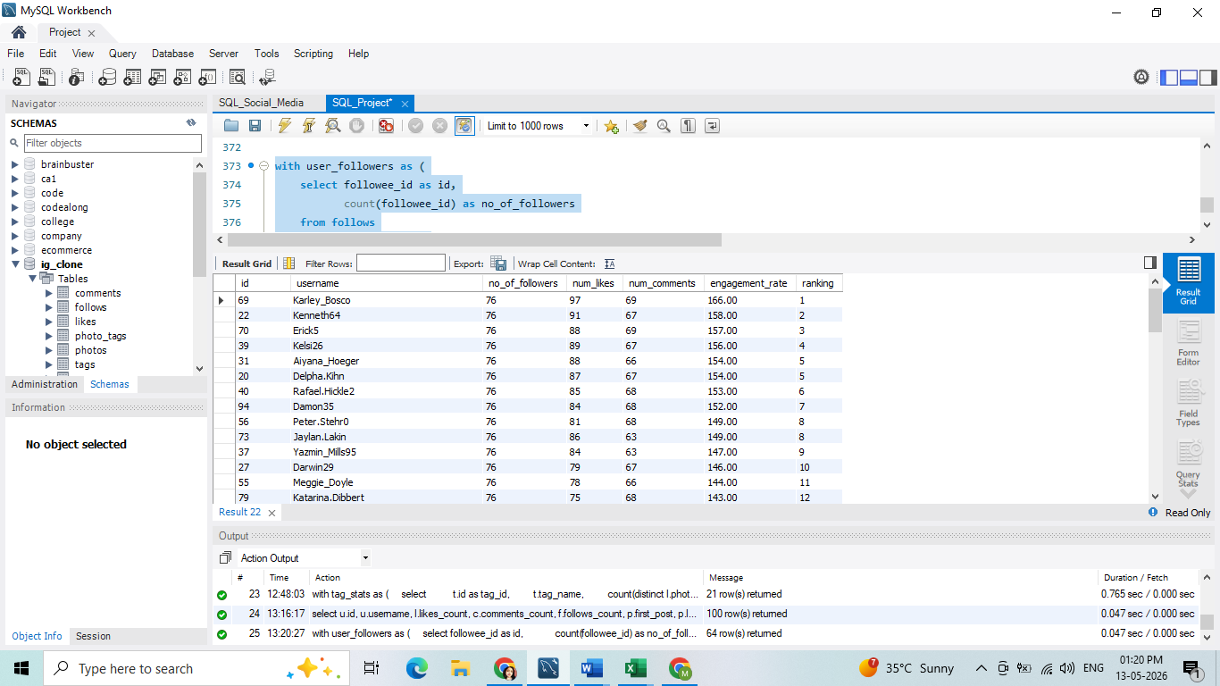

Insights:
- All users have the same follower count (76)
This indicates that the platform's follower distribution is even or this is a sample. Hence, engagement rate becomes the primary differentiator for identifying influencers.
- Engagement rate is highly varied
  - Some users have extremely high engagement rates (e.g. Karley_Bosco → 166.00, Kenneth64 → 158.00, Erick5 → 157.00).
  - Others are much lower (e.g. Colten, Harris76 → 28.60, Kathryn 80 → 29.80).
- Top performers stand out
Users like:
  - Karley_Bosco, Kenneth64, Erick5, Delpha.Kihn, Aiyana_Hoeger, etc., are excellent candidates.
They have high interaction with their content despite having the same follower base.
Engagement is not directly correlated with follower count
Even though all users have the same followers, some posts are much more engaging — meaning content quality, timing, and interaction matter more.
Recommendations:

➤ Select users with high engagement rates
- Prioritize users with engagement rates above 75.00, as they consistently attract likes and comments.
- Top influencers include:
  - Karley_Bosco (166.00)
  - Kenneth64 (158.00)
  - Erick5 (157.00)
  - Delpha.Kihn (154.00)
  - Aiyana_Hoeger (154.00)

➤ Diversify influencer selection
- Select influencers from various engagement levels (top 5, mid-range, and niche).
- This ensures reaching both mass and targeted audiences.

➤ Approach strategies
- Personalized outreach
  - Highlight why their engagement stands out.
  - Offer collaboration opportunities that match their content style.
- Offer performance-based incentives
  - Provide bonuses or rewards tied to engagement rather than just reach.
- Encourage authentic content
  - Influencers with high engagement are likely trusted by their audience — ensure that brand messages align with their voice.
- Track and optimize
Regularly monitor engagement patterns to adjust partnerships and campaigns in real time.
6. Based on user behavior and engagement data, how would you segment the user base for targeted marketing campaigns or personalized recommendations?

Answer:

select u.id, u.username,

coalesce(p.num_photos, 0) as num_photos,

coalesce(l.num_likes, 0) as num_likes,

coalesce(c.num_comments, 0) as num_comments,

coalesce(f.follows_count, 0) as follows_count,

case

when coalesce(p.num_photos, 0) = 0 then 0

else round(

(coalesce(l.num_likes, 0) + coalesce(c.num_comments, 0))

/ coalesce(p.num_photos, 1),2

)

end as engagement_rate,

case

when coalesce(p.num_photos, 0) >= 50

and (

case when coalesce(p.num_photos,0)=0 then 0

else (coalesce(l.num_likes,0)+coalesce(c.num_comments,0))/coalesce(p.num_photos,1)

end

) >= 50 then 'highly engaged'

when coalesce(p.num_photos, 0) >= 20 then 'active user'

when coalesce(p.num_photos, 0) < 5 then 'new or passive'

else 'general user'

end as segment

from users u

left join (

select user_id, count(*) as num_photos

from photos

group by user_id

) p on u.id = p.user_id

left join (

select p.user_id as user_id, count(*) as num_likes

from likes l

join photos p on l.photo_id = p.id

group by p.user_id

) l on u.id = l.user_id

left join (

select p.user_id as user_id, count(*) as num_comments

from comments c

join photos p on c.photo_id = p.id

group by p.user_id

) c on u.id = c.user_id

left join (

select follower_id as user_id, count(*) as follows_count

from follows

group by follower_id

) f on u.id = f.user_id

order by engagement_rate desc;

Approach:
The query aggregates user activity from multiple tables (photos, likes, comments, follows) using left joins and COALESCE to handle missing data. It calculates engagement per post and uses CASE statements to assign users into meaningful segments based on post counts and engagement.
Steps:
- Selected all users from the users table as the base.
- Left joined a subquery to count total photos uploaded per user (num_photos).
- Left joined a subquery to count total likes received on user photos (num_likes).
- Left joined a subquery to count total comments received on user photos (num_comments).
- Left joined a subquery to count total followers per user (follows_count).
- Calculated engagement_rate as (num_likes + num_comments) ÷ num_photos, rounded to 2 decimals.
  - Used COALESCE to handle cases where a user has zero photos.
- Used a CASE statement to segment users based on their activity and engagement:
  - Highly engaged: ≥50 posts and engagement rate ≥50.
  - Active user: ≥20 posts.
  - New or passive: <5 posts.
  - General user: all others.
- Ordered the results by engagement_rate DESC to highlight the most engaging users.

Result:
Delivered a detailed view of user activity, engagement, and segmentation, helping the platform:
- Identify top contributors and highly engaged users.
- Recognize new or passive users for re-engagement campaigns.
- Track overall user engagement trends.
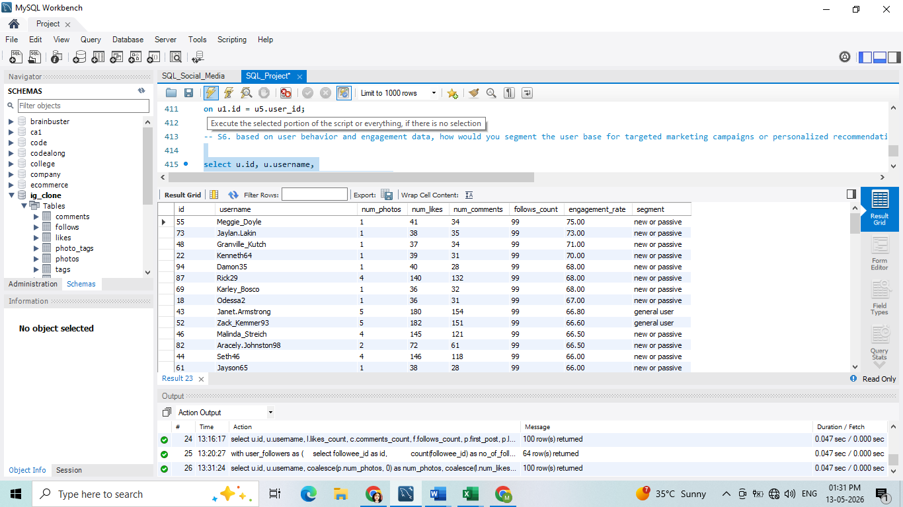
Insights:

1. New or Passive Users
- Profile: Few or no photos posted, very high engagement on the rare content they do post (e.g., 1–4 photos but hundreds of likes/comments), or completely inactive (0 photos).
- Risk: High churn risk; they consume content but contribute little, or they are new sign-ups who haven’t formed a habit.
- Actions:
- Onboarding campaigns: Tutorials, notifications, or “first post challenges” to push them to upload more.
  - Personalized recommendations: Show trending/relevant content and highlight “similar users” to spark activity.
  - Incentives: Badges, streaks, or small rewards when they hit milestones like 5 posts or first 50 likes.

2. General Users
- Profile: Moderate posting frequency (5–15 photos), engagement rate between 60–65%. They form the “middle bulk” of the platform.
- Opportunity: Can be nurtured into more active contributors.
- Actions:
  - Content feedback loop: Provide analytics dashboards (e.g., “Your last photo got 20% more likes than average!”).
  - Push notifications: Encourage them to post again if inactive for >7 days.
  - Personalized suggestions: Recommend hashtags, posting times, or communities where similar users thrive.

3. Active Users
- Profile: Post volume ≥20 photos, engagement rate solid but below “viral.” They are consistent contributors.
- Value: Drive daily activity and content availability for others.
- Actions:
  - Creator support: Offer advanced tools (editing, scheduling, insights).
  - Community roles: Invite them to join beta features, moderate groups, or test events.
  - Monetization: Encourage partnerships, sponsorships, or brand collaborations.

4. Highly Engaged Users
- Profile: ≥50 photos with engagement rate ≥50. These are your influencers/brand advocates.
- Value: High reach, high engagement, can influence passive users.
- Actions:
  - Ambassador program: Give them badges, exclusive invites, or partnerships.
  - Early access: Let them test new features first — they’ll spread word-of-mouth.
  - Cross-promotion: Highlight their content in “Recommended” or “Editor’s Picks.”
Recommendations:
- Segmentation-driven campaigns:
- Retention focuses on “new/passive” with nudges and onboarding.
  - Engagement boosting for “general users” with gamification.
  - Community empowerment for “active users.”
  - Influencer collaboration with “highly engaged” users.
- Personalization in feed & notifications: Show each group different content based on their behavior.
Lifecycle marketing: Track when users move from “new” → “general” → “active” → “highly engaged” and celebrate the transition (e.g., “Congrats, you’re now a Top Creator!”).
7. If data on ad campaigns (impressions, clicks, conversions) is available, how would you measure their effectiveness and optimize future campaigns?

Answer:

select ac.id,ac.name,
count(distinct i.id) as impressions,
count(distinct c.id) as clicks,
count(distinct cv.id) as conversions,
(count(distinct c.id) / count(distinct i.id)) * 100 as ctr, -- click-through rate
(count(distinct cv.id) / count(distinct c.id)) * 100 as cvr, -- conversion rate from clicks
(count(distinct cv.id) / count(distinct i.id)) * 100 as overall_conversion_rate
from ad_campaigns ac
left join impressions i on ac.id = i.ad_campaign_id
left join clicks c on i.id = c.impression_id
left join conversions cv on c.id = cv.click_id
group by ac.id, ac.name;

Approach:
The query aggregates data from ad_campaigns, impressions, clicks, and conversions. Using LEFT JOINs, it ensures campaigns with no activity are still included. Metrics such as CTR and conversion rates are calculated using counts of distinct events to avoid double-counting.

Steps:
- Selected the ad_campaigns table as the base.
- Left joined impressions to count total impressions per campaign.
- Left joined clicks to count total clicks associated with each impression.
- Left joined conversions to count total conversions associated with each click.
- Calculated CTR as (clicks ÷ impressions) × 100 to measure how often users clicked ads.
- Calculated CVR as (conversions ÷ clicks) × 100 to measure how often clicks led to conversions.
- Calculated overall conversion rate as (conversions ÷ impressions) × 100 to measure end-to-end ad effectiveness.
- Grouped by ac.id and ac.name to get metrics per campaign.
Result:
Delivered a comprehensive ad performance report, helping marketing teams:
- Identify campaigns with high engagement (CTR) and high conversion efficiency (CVR).
- Track total impressions, clicks, and conversions for ROI analysis.
- Optimize ad strategy by focusing on high-performing campaigns.

Recommendations for Optimization:
Audience Segmentation
- Break down CTR and CVR by audience attributes such as age, device type, location, and time of day.
- This helps uncover where campaigns perform best and where adjustments are needed.
A/B Testing & Experimentation
- Run experiments on ad copy, visuals, CTAs, and landing pages.
- Use data-driven insights from these tests to refine campaigns and boost performance.
Attribution & Funnel Analysis
- Move beyond last-click attribution and look at how campaigns contribute across the customer journey.
- This prevents undervaluing campaigns that are effective at driving awareness or mid-funnel engagement.
Ad Quality & Relevance
- On platforms like Google and Facebook, higher relevance scores can lead to lower CPC.
- Focus on improving ad messaging and alignment with audience intent to raise quality scores.
Customer Lifetime Value (LTV)
- Don’t focus only on immediate conversions.
Track long-term value to identify campaigns that bring in high-quality, loyal customers, even if the initial CPA is higher.

8 How can you use user activity data to identify potential brand ambassadors or advocates who could help promote Instagram's initiatives or events?

Answer:
with post_counts as (
select user_id, count(*) as total_posts
from photos
group by user_id
),
comment_counts as (
select user_id, count(*) as total_comments
from comments
group by user_id
),
like_counts as (
select user_id, count(distinct photo_id) as total_likes
from likes
group by user_id
),
follower_counts as (
select followee_id as user_id, count(*) as total_followers
from follows
group by followee_id
),
tag_usage as (
select p.user_id, group_concat(distinct t.tag_name) as hashtags_used
from photos p
join photo_tags pt on p.id = pt.photo_id
join tags t on pt.tag_id = t.id
group by p.user_id
)
select u.id as user_id, u.username,
coalesce(pc.total_posts, 0) as total_posts,
coalesce(cc.total_comments, 0) as total_comments,
coalesce(lc.total_likes, 0) as total_likes,
coalesce(fc.total_followers, 0) as total_followers,
case
when coalesce(pc.total_posts, 0) = 0 then 0
else round((coalesce(lc.total_likes, 0) + coalesce(cc.total_comments, 0)) / pc.total_posts, 3)
end as engagement_rate, tu.hashtags_used,
case
when coalesce(pc.total_posts, 0) > 5
and (coalesce(lc.total_likes, 0) + coalesce(cc.total_comments, 0)) / nullif(pc.total_posts, 0) > 0.2
then 'high engagement user'
when coalesce(fc.total_followers, 0) > 50
and (coalesce(lc.total_likes, 0) + coalesce(cc.total_comments, 0)) / nullif(pc.total_posts, 0) > 0.1
then 'potential influencer'
when tu.hashtags_used like '%#instagram%'
or tu.hashtags_used like '%#event%'
then 'event advocate'
else 'other'
end as user_segment
from users u
left join post_counts pc on u.id = pc.user_id
left join comment_counts cc on u.id = cc.user_id
left join like_counts lc on u.id = lc.user_id
left join follower_counts fc on u.id = fc.user_id
left join tag_usage tu on u.id = tu.user_id
where coalesce(fc.total_followers, 0) > 50
and (
case
when coalesce(pc.total_posts, 0) = 0 then 0
else (coalesce(lc.total_likes, 0) + coalesce(cc.total_comments, 0)) / pc.total_posts
end
) > 0.1
order by total_followers desc, engagement_rate desc;

Approach:

The query aggregates user activity from multiple tables (photos, comments, likes, follows, tags) using CTEs. It calculates engagement rate per post and uses conditional logic (CASE) to segment users based on activity, influence, and hashtag usage. A filter ensures that only users with meaningful engagement and followers are included.
Steps:
- Aggregate key metrics per user: posts, comments, likes, followers, and hashtags.
- Join all metrics with the users table.
- Calculate engagement rate as (likes + comments) ÷ posts.
- Segment users using CASE based on posts, engagement rate, followers, and hashtags.
- Filter users with >50 followers and engagement rate >0.1.
- Order results by total_followers and engagement_rate descending.
Result:
Delivered a segmented list of influential and highly engaged users, including metrics, engagement rate, and hashtag usage. This enables marketing teams to:
- Identify potential influencers for campaigns,
- Recognize users with strong engagement for promotions,
- Track hashtag advocates and content trends.
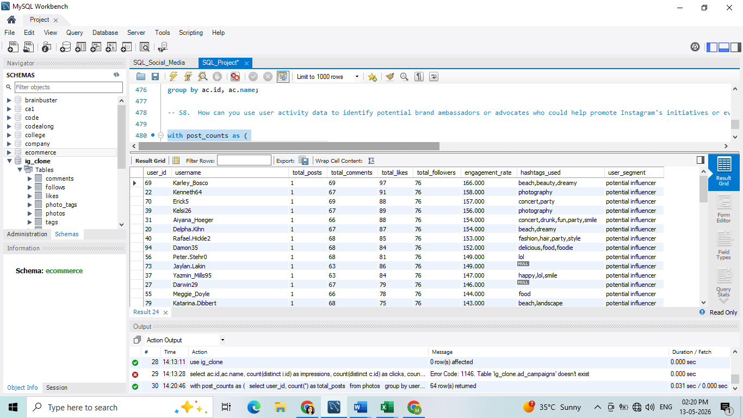

Insights :
- High Engagement Users (≈ Engagement Rate > 20%)
  - These users post actively, and their likes + comments per post are high.
  - They may not always have massive follower counts, but their influence within their niche is strong.
- Potential Influencers (Followers > 50 and Engagement Rate > 10%)
  - These users have more than 50 followers (adjustable threshold) and maintain solid engagement.
  - They strike a balance between reach (audience size) and decent interaction.
- Event Advocates (Hashtags: #instagram, #event, etc.)
  - They already show loyalty by tagging Instagram- or event-related hashtags.
  - They naturally amplify campaigns related to Instagram initiatives.
- Other Users
  - Active, but not strong in engagement, reach, or advocacy.
  - Still useful for participation in broader challenges or to boost engagement metrics.

Recommendations:
- For High Engagement Users
  - Action: Enroll them in brand ambassadorship programs or exclusive content launches.
  - Why: Their strong influence per post ensures organic reach and trust-driven promotion.
- For Potential Influencers
  - Action: Partner with them for sponsored posts, collaborations, or event promotions.
  - Why: They combine follower base + engagement → good for generating campaign buzz.
- For Event Advocates
  - Action: Use them as event promoters or campaign voices. Invite them early for beta features, new events, or hashtag campaigns.
  - Why: They already have alignment with Instagram-related events, making their advocacy authentic.
- For Other Users
  - Action: Encourage through gamified challenges, reels competitions, or engagement campaigns.
  - Why: They may not have big reach, but collectively they can drive visibility.
- Overall Strategy
  - Focus first on high-engagement users and potential influencers for influencer campaigns.
  - Leverage event advocates for event promotions and loyalty-driven campaigns.
Boost UGC (user-generated content) by empowering content creators and nudging passive consumers.
9. How would you approach this problem if the objective and subjective questions weren't given?
Answer:

If the objective and subjective questions weren't given, I would approach this social media analysis by focusing on a structured, business-driven frameworks designed to maximize user engagement, retention, and platform monetization.

Here is the strategic breakdown of how I would approach the dataset:

1. Define Business Goals & Success Metrics
The first step is to establish what success looks like for the platform and align our data exploration with core business pillars:

- Engagement: How actively are users consuming and interacting with content (likes, comments, and tags per post)?

- Retention & Loyalty: How consistently do users return and participate over time (identifying daily/monthly active cohorts vs. churn risks)?

- Platform Health: Assessing data integrity, duplicate entry risks, and mapping out the data schema to ensure accurate reporting.

2. Global Data Audit & Schema Mapping
Before writing analytical queries, it is critical to verify data health to avoid skewed insights:

- Sanity Checks: Scan key tables (users, photos, likes, comments, follows, tags) for missing values (NULLs) in essential text fields or timestamps.

- De-duplication: Use aggregation checks (GROUP BY ... HAVING COUNT(*) > 1) to ensure primary keys and specific unique actions (like a user liking the same post twice) are valid.

- Structural Prevention: Recommend strict constraints like NOT NULL rules and unique indexes to engineering teams to maintain future data purity.

3. User Segmentation Modeling
Instead of looking at the user base as a single monolith, I would segment users based on their volumetric output and interaction patterns to uncover behaviors:

Segment | Behavior Profile | Primary Risk / Opportunity
New / Passive Users | 0 to 4 posts; highly skewed or completely absent interactions. | High churn risk. Consuming without contributing.
General Users | Moderate activity (5–15 posts); stable engagement rates (~60–65%). | Core audience. High growth potential to convert to active users.
Active Users | Consistent posting (20+ posts); regular community interaction. | Platform engine. Drive daily activity and content availability.
Highly Engaged (Influencers) | High post volume (50+) paired with top-tier engagement rates. | Brand Advocates. High reach to influence passive consumers.

4. Content & Hashtag Performance Optimization
Understanding what content works helps scale organic discovery:

- Topic Clusters: Analyze which tag categories generate disproportionately high interaction-to-post ratios (e.g., assessing visual categories like food, lifestyle, and scenic content vs. event tags).

- Tag Density: Track the average number of tags per post to find out if users are optimizing their captions for discoverability or leaving visibility on the table.

5. Network Dynamics & Reciprocity Analysis
A healthy network relies on dynamic bidirectional connections. I would look closely at follower/following relationships:

- Passive Influencers vs. Power Connectors: Compare users with high follower counts but zero outward followings against proactive network users.

- Reciprocity Context: Run self-joins on follow tables to observe mutual follow-back trends over time, highlighting how organically communities are forming.

6. Actionable Marketing Recommendations
Data is only valuable if it drives action. Based on these systemic findings, I would deliver structured playbooks to marketing teams:

- Re-engagement Funnels: Nudge inactive and zero-post users with automated notifications, personalized content recommendations, and onboarding challenges.

- Gamification Systems: Implement milestones, streaks, and digital badges for general users to increase their daily app interactions.

- Influencer Pipeline: Identify top engagement-rate outliers for localized brand ambassador programs and exclusive content drops.

10.Assuming there's a "User_Interactions" table tracking user engagements, how can you update the "Engagement_Type" column to change all instances of "Like" to "Heart" to align with Instagram's terminology?
Answer:

update User_Interactions
set Engagement_Type = 'Heart'
where Engagement_Type = 'Like' ;

Approach:
The goal is to align terminology in your engagement data with Instagram’s standard. Right now, your table records "Like", but Instagram calls the same action "Heart". So, we’ll update all existing records to match the new standard.

Insights:
- Consistency: Using "Heart" aligns your data with Instagram’s official terminology, which improves clarity for analysts, marketers, and stakeholders.
- Data Quality: This prevents confusion where some rows say "Like" and others say "Heart". Consistent labels make reporting cleaner.
- Future Readiness: If you plan to integrate with APIs, dashboards, or analytics tools, having standardized terms makes mapping and visualization smoother.
- Recommendation: Document this change in your data dictionary so everyone knows "Heart" = Instagram’s engagement metric.

Schema Diagram for ig_clone DATABASE

